**Police renew call for installation of lightning arresters-Uganda**

<https://www.newvision.co.ug/category/news/police-renew-call-for-installation-of-lightni-NV_199095>

05 November 2024|  
  
This development comes after lightning struct 34 people in Northern Uganda leaving 14 people dead  
  
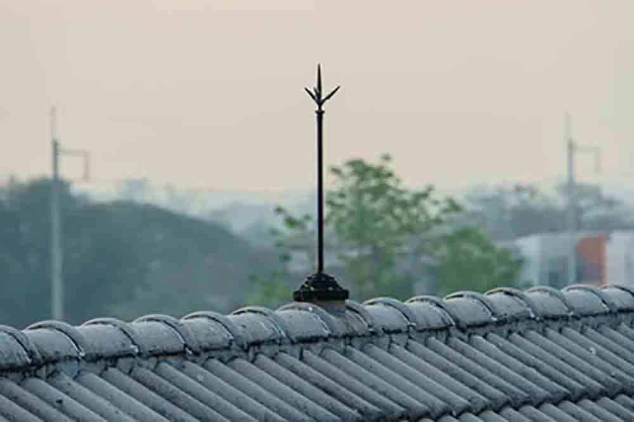

By John Masaba  
  
“Our preliminary investigations generally reveal a concerning absence of lightning infrastructure,” Uganda Police spokesperson Kituuma Rusoke said on Monday, November 4, 2024.

This development comes after lightning struck 34 people in northern Uganda leaving 14 people dead. The incident took place on Sunday during a prayer service at a church located in Zone VIII in Palabek Settlement where the victims had gathered.

Kituuma said they managed with other agencies to evacuate the survivors to Palunga Health Centre III for medical attention, adding that by Sunday, 13 victims had been discharged.

“Just a day before there was another incident in Abim town council where at about 2:00pm lightning struck Akello Sharon, a 15-year-old pupil at Aninata Primary School in Abim sub-county, who was playing outside when rain started falling,” he said.

He said at the time of her death, the pupil had taken shelter under a tree which also served as a partial classroom.

He said by the time of the incidents none of the locations (Palabek and Abim) had lightning arresters which made the victims extremely vulnerable.

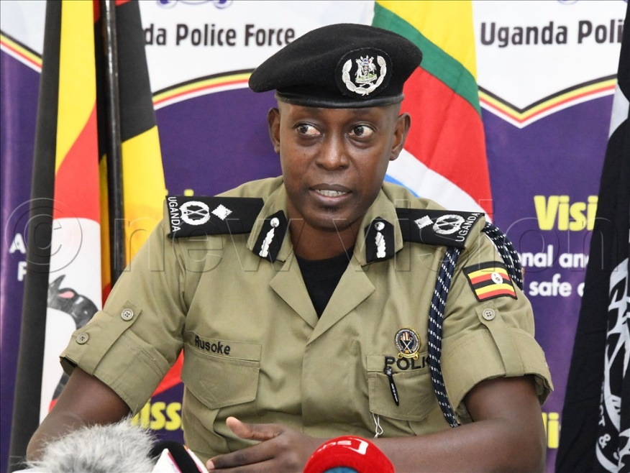

*Uganda Police spokesperson Kituuma Rusoke. (New Vision/Files)*

**Safety measures**  
  
Speaking during the weekly joint security briefing at the Uganda Police headquarters in Naguru on Monday, Kituuma said with the onset of rains, incidents of lightning have become likelier than before.

According to him, the locations where most people are killed or injured include classrooms, taking shelter under trees, grazing cattle in the field and walking in the open and inside houses.

He urged the public to ensure that people always seek shelter in closed buildings.

“Avoid structures that are not closed and pavilions or tents which do not provide adequate protection,” he said, adding that acts like fetching water outside during rains which are common in villages should be avoided.

“We also advise people who especially use water transport where possible to go to the shores because water is a high conductor of electric current.”

Gulu, Lira, Hoima, Jinja, Kalangala and Kisoro are some of the districts with the most occurrences, deaths and also those injured according to a recent report by the Uganda Meteorological Authority.