**15 killed as storms lash eastern Chad**

AFP

05 September 2024

https://www.arabnews.com/node/2570261/amp

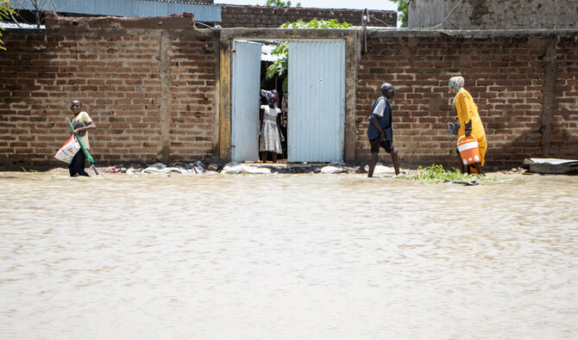Residents of Boutal-Bagar district walk through a flooded street in N’Djamena on August 5, 2022, following the first major rains of the season. (AFP/File)

**Short Url**

https://arab.news/bhy93

N’DJAMENA:  At least fifteen people — 14 students and their teacher — were killed overnight from Wednesday to Thursday as torrential rains hit a semi-arid province in eastern Chad, officials said.

The governor of Ouaddai province told AFP that the storms caused a home being used as a classroom to collapse, “causing the death of 15 people, including 14 children and their teacher.”

The prime minister’s office meanwhile said that “lightning tragically struck a school, resulting in the death of 15 people and several injured.”

Heavy rainfall had already inundated the northwestern province of Tibesti last month, when flooding killed at least 54 people in an area where rainfall normally struggles to reach 200 mm (nearly eight inches) a year.

The United Nations on Tuesday warned of the impact of “torrential rain and severe flooding” in central Africa, noting that “Chad is the country hit hardest, with 246,833 people impacted by floodwaters in just a few weeks.”

In neighboring Niger, rains that have pounded the country since June have killed 273 and affected more than 700,000, authorities said on Wednesday.

Scientists have long warned that climate change driven by fossil fuel emissions is making extreme weather events such as floods more frequent, intense and longer-lasting.