Lightening Kill 2 People in Sironko - Uganda
Omagor Markson 3 weeks ago

24 October 2024

https://eastnews.co.ug/2024/10/23/lightening-kill-2-people-in-sironko/

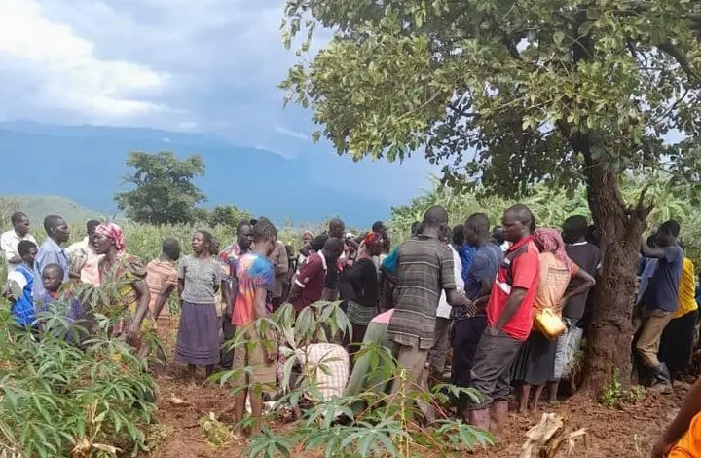 Residents at the scene where the two were struck by lightning
By Weswa Ronnie

SIRONKO

Lightning has struck and killed two people on the spot in Sironko district.

The deceased who met their deaths on Tuesday evening, 22nd October, 2024 have been identified as Joseph Masaba aged 35 years and Charles Makabayi aged 22 years, all residents of Dahami Sub County.

Stephen Gudoi, one of the eyewitnesses says that the incident happened at 6 pm during a heavy downpour.

He says that the two were digging in the garden after seeing rain they went and took shelter under a tree when the tragic incident happened.

Frank Muzoora, the Sironko district police Commander has confirmed the incident saying the bodies were taken by relatives for burial.

He cautioned people against sitting or taking shelter under trees when it is raining in order to avoid similar incidents.

