# Zambezi farmers seek government aid after lightning kills cattle - Namibia <https://nbcnews.na/node/109548#google_vignette>15 February, 2025

By Juliet Sibeso

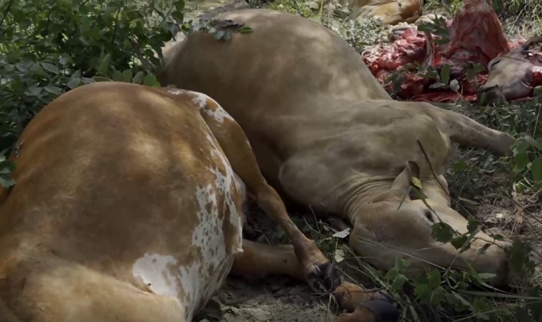

Farmers in the Zambezi Region are appealing for government support following the devastating loss of their cattle to lightning strikes.

For many of these farmers, cattle are their primary source of livelihood, and the recent incidents have left them in urgent need of assistance to recover.

The incident took place at Kaenda Village on Wednesday afternoon, where three different farmers each lost their animals.

One of the cattle herders, Masiye Kambungu, gave an account of what happened.

"We were coming from the feeding pastures, heading home. It happened while we were heading back to the village; it started raining. The cattle were struck by lightning and died on the spot—it was shocking."

58-year-old Agrey Luseso lost eleven cattle.

He said he received a phone call just as he left work, informing him of trouble at his farm.

"I was informed of the lightning at the Kraal at the time it was raining. I tried to get hold of the helpers at the farm and eventually received information that eleven cattle had died, but upon further investigations, it was confirmed to be fourteen in total. It was three young bulls, one big bull, and the rest all cows."

Lusso estimates his loss at between N$150,000 and N$200,000, stating that all of them were crossbreeds and Brahman cattle.

He explained the need for government assistance, stating that the loss is huge, brought on by a natural disaster that he cannot recover from without help.

Libonina Liswaniso, who is a member of the village development committee, reiterated the need for government assistance.

"When I look at the loss here, these people worked very hard to secure a breed of cattle that is not common in this region. It is very sad that it is the same cattle that died in the incident; I believe the loss to be around N$150-170 or N$200,000."

The village induna, Michael Kaenda, further reiterated the call for assistance for the farmers to recover from the losses.

"I am standing here because of the tragedy that befell my people. These cattle belong to three different people, one of whom lost eleven, the second owner lost two, and the third owner lost one. It is a very tragic loss, one we have not yet experienced in this area—we only hear of such incidents happening in other areas. For us, it's like a herd of elephants buying at once—it is a sad situation. I am asking that the government look to my children and see how they can be helped, as this has been their livelihood.”