**New weather alert after 14 killed by lightning strikes as storms lash Yemen-Yemen**<https://www.arabnews.com/node/2568206/amp>  
  
20 August, 2024

Saeed Al-Batati

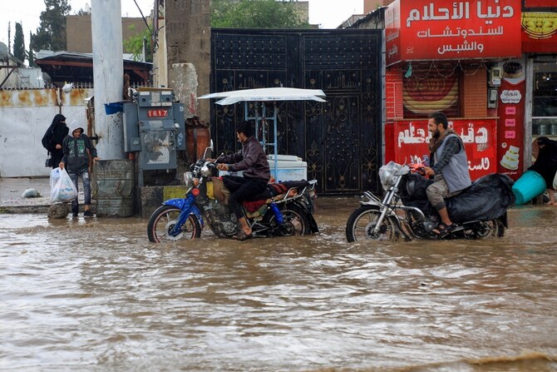

1Heavy rains since July has caused flash floods that have killed over 100 people and displaced many more . (AFP/File)

AL-MUKALLA: Weather chiefs in Yemen issued a new warning on Tuesday after 14 people were killed by lightning strikes in the northern province of Hajjah.

Lightning killed three people during thunderstorms in Abbes, three in Kuhlan Affar and eight more in other parts of the province. The National Center of Meteorology said there would be severe weather conditions over the next 24 hours.

Heavy rain since July has caused flash floods that have killed over 100 people and displaced many more in Hodeidah, Ibb, Hajjah, Sanaa, Marib, and other provinces. At least 600 people were injured by flooding in Hodeida and Marib alone, the UN humanitarian agency OCHA said, and 13 people were still missing in Hodeida and Taiz.  
  
It said a total of 38,285 families — nearly 268,000 people — had lost their homes. “Public infrastructure, including schools, roads, and health facilities, have been affected. Livelihoods that were already hanging by a thread have been swept away,” OCHA said. “Severe weather is expected to persist into September, with additional alerts for heavy rainfall.”  
  
Yemen suffers from severe floods triggered by torrential rainfall nearly every year. The University of Notre Dame’s Global Adaptation Initiative ranks Yemen as one of the region’s most climate-vulnerable countries. In recent years it has experienced an increase in the frequency and intensity of rainfall due to climate change, stimulated by atmospheric circulation in the Indian Ocean.  
  
The country also suffered heavy flooding in 2019, 2020 and 2021.