Lightning Strikes Within Chido as it Approaches Landfall- Mozambique
https://satlib.cira.colostate.edu/loop_of_the_day/lightning-strikes-within-chido-as-it-approaches-landfall/
December 16, 2024
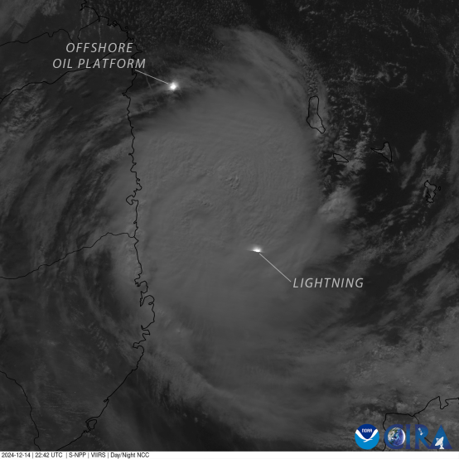
Daily Loop:
A lightning strike shined brightly within Tropical Cyclone Chido as it approached the coast of Mozambique. The lights from an oil platform off the coast were visible through the clouds of Chido’s outer bands.

