**Lightning kills 50 cows worth 40m/- in - Tanzania**  
  
<https://dailynews.co.tz/lightning-kills-50-cows-worth-40m-in/>

16 January, 2025

By [Peti Siyame](https://dailynews.co.tz/lightning-kills-50-cows-worth-40m-in/)

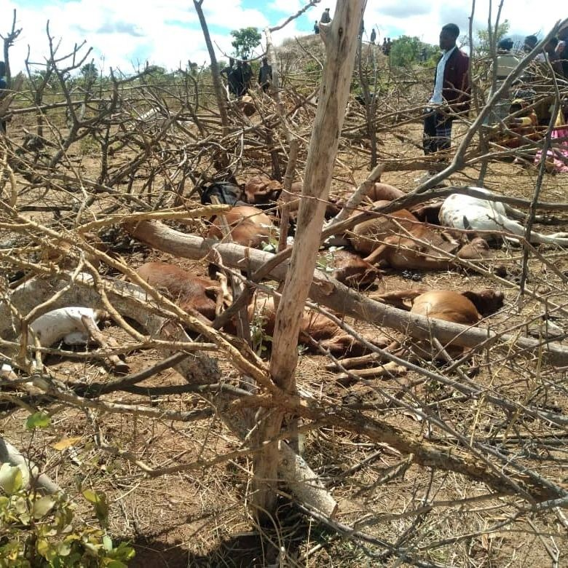

**RUKWA:** ABOUT 50 cows valued at over 40m/- have been killed instantly by lightning strikes between December last year and January this year in Rukwa Region.

The incidents, which have devastated local residents, occurred across Nkasi, Sumbawanga and Kalambo Districts. In each case, three boys who were grazing the cows narrowly escaped death.

The most recent incident occurred on January 13, 2025, when 10 cows belonging to Steven Silanda were killed by lightning while grazing in Mwenge Village, Kate Ward, Nkasi District.

Advertisement

Kate Ward Executive Officer, Mr Deus Njugu reported that fifteen cows were grazing in the area when the lightning struck, killing ten on the spot.

The remaining five cows were unharmed.

In another incident in Kalambo District, sixteen cows were killed by lightning while illegally grazing in the Kalambo Natural Forest Reserve earlier in January.

The Kalambo District Council Veterinary Officer, Dr Enos Luvinga confirmed the incidents saying the cows were killed by lightning strikes. As a precaution, Dr Luvinga ordered that all the carcasses be burnt to prevent health risks to the community.

“The carcasses of cows killed by lightning are unfit for human consumption, if consumed, they could pose serious health risks,” he warned.

Mr Ibrahim, the district conservation officer, also issued a stern warning about illegal activities in forest reserves.

“Entering and carrying out activities such as farming, cutting trees, or grazing livestock in reserved forests is prohibited,” he said.

He added: “Anyone caught violating this will face legal action.” Earlier, on December 8, 2024, another tragic incident occurred in Songambele-Azimio Village, Sumbawanga, when 22 cows, belonging to the pastoralist Fale Jaba Keleja, were struck by lightning and killed instantly.

Sumbawanga District Administrative Secretary, Mr Gabriel Masinga confirmed that the lightning strike claimed the lives of the cows in this unfortunate event.

The incidents highlight the risks posed by lightning strikes and the ongoing challenges of protecting livestock in rural areas.