**Lightning Strike Claims Two Cows in Kiruhura District - Uganda**

Unpublished -- Investigated w photo by our staff – Barnaba Akantambir

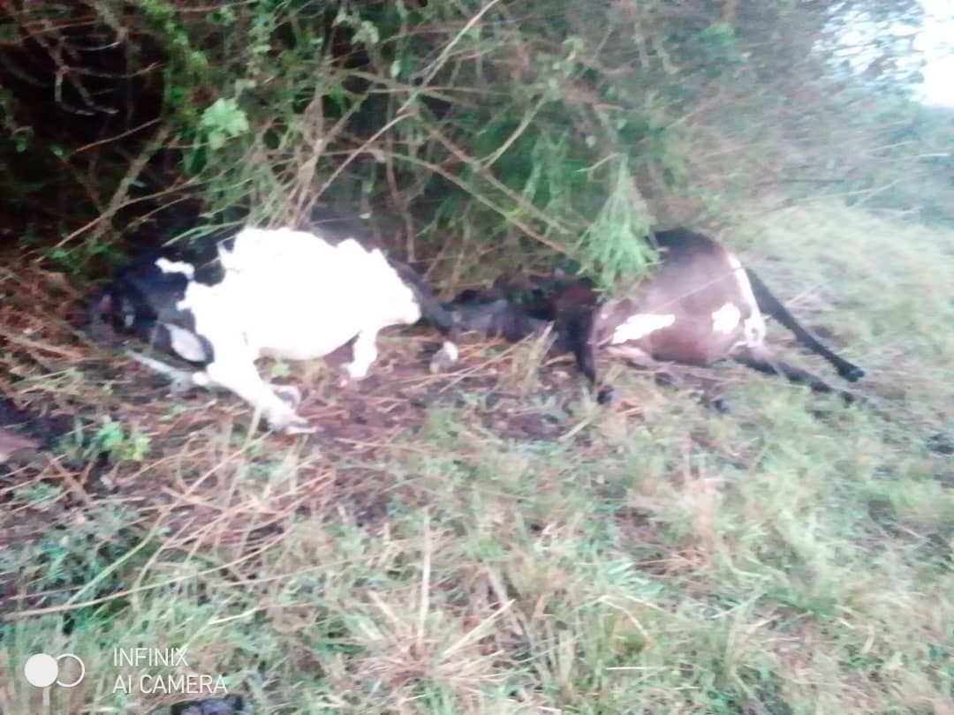

Photos of the two cows that fell victim to the lightning strike.

19 October, 2024  
  
A devastating lightning strike killed two cows belonging to Abel Bagwera, a local farmer in Kiruhura district.

According to eyewitnesses, the incident took place at approximately 1:00 PM on October 19, 2024, at Kikatsi Cell in Kikatsi Subcounty. The cows were grazing in an open field when the sudden lightning strike hit, claiming their lives instantly.