# Lightning strikes six Amuria Man Utd fans during Ipswich match- Uganda

##### <https://www.newvision.co.ug/category/news/lightning-strikes-six-amuria-man-utd-fans-dur-NV_200307#google_vignette> Even 14 Nov 2024, reported 27 Nov

##### By Patrick Eteu Journalist @New Vision

**The drama wasn't just on the pitch when six die-hard Manchester United fans in Uganda's Amuria district found themselves on the receiving end of nature's own VAR – a bolt of lightning – while watching their beloved team play.**  
  
As the Red Devils fought it out with Ipswich on the screen on Sunday, November 14, 2024, the heavens seemingly weighed in, leaving the Olwa sub-county, Olwa trading centre-based fans both stunned and singed. Miraculously, all only sustained injuries after they were struck.  
  
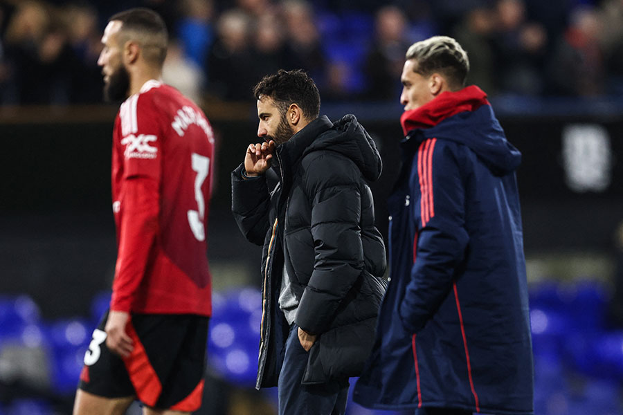Ruben Amorim (c), who replaced the sacked Ten Hag earlier this month, saw his first game end in a 1-1 draw at Ipswich. (File)

United are 12th in [the Premier League](https://www.newvision.co.ug/category/news/lightning-strikes-six-amuria-man-utd-fans-dur-NV_200307) table after a poor start to the season, six points off the top four teams, who qualify for the Champions League.  
  
Simon Opila aka Akapun, the Chairperson of Manchester United fans in Olwa sub-county who also happened to be the victim, on Monday, November 25, 2024, said they were busy enjoying the match when the incident occurred.  
  
According to Opila, one of the victims was badly off but later regained his senses.  
  
Ojenit village LC1 chairperson, James Arama, confirmed the incident saying six people sustained injuries from the lightning strike.  
  
He says the incident has caused worry among the residents since this is the third time lightning has struck this centre.  
  
As the fans nurse lightning strike injuries, the club is also nursing a financial injury. Reports reaching New Vision Online indicate that the club suffered a £14m ($17.6m) drop in total revenue to £143.1m, taking a hit from their absence from the lucrative Champions League. This is according to the club's first-quarter results released on Tuesday, November 26, 2024.  
  
But the club announced a net profit of £1.4m in the period from July to September, compared with a £25.8m loss during the same period last year, which they attributed to favourable foreign exchange rates.  
  
**Other strikes around the country**Lightning strikes are uncommon in much of Uganda, but there are areas they have struck and turned fatal for the victims.  
  
This year alone, lightning strikes have claimed over 10 lives. [On November 2, a lightning strike hit a Catholic chapel in Palabek Refugee Settlement's Zone 2, Block 8, killing 14 people,](https://www.newvision.co.ug/category/news/18-lightning-strike-survivors-discharged-from-NV_198973) while 34 others were left with multiple injuries.  
  
Lightning strikes claimed over five lives in 2023 around the country.  
  
For instance, on September 6, 2023, it was a double tragedy in Yumbe district after lightning struck two children dead.  
  
On March 16, 2023, two members of the same family in Rukungiri district died on the spot after they were struck by lightning.