**Three Women Hospitalized After Lightning Strike at Church in Rubanda District - Uganda**  
  
<https://kigezitv.com/news/story/three-hospitalized-in-rubanda-after-lightning-strike/>

20 October, 2024  
  
By Ambrose Kweronda

**Three Hospitalized in Rubanda After Lightning Strike**Three women were hospitalized after being struck by lightning at Mengo Church of Uganda in Mengo Parish, Nshanjare Town Council, Rubanda District. The incident occurred around 2 p.m. on Sunday, October 20, 2024, following a Sunday service.

Ven. Earnest Nkwasibwe, the Archdeacon of Muko Archdeaconry where the church is located, confirmed that the lightning strike injured three women identified as Charity Murungi (35), Brenda Nyiramutuzo (33), and Macklean Tumusingize (30), all residents of Mengo Village in Mengo Ward, Nshanjare Town Council and they were rushed to Muko church of Uganda HCIII .

Ven. Nkwasibwe urged the Rubanda District leadership to equip worship centres and nearby schools with lightning conductors to prevent such incidents in the future.

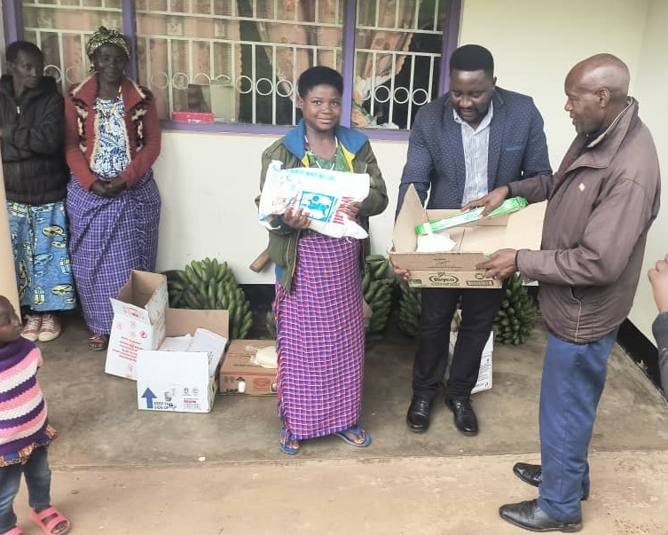

In response to the tragedy, Rubanda West Member of Parliament hopeful 2026-2031, Mucunguzi Innocent Rwakiiseta, visited the affected families, providing relief items including matooke, rice, salt, soap among others to assist them during this difficult time.

He also reminded the public to observe lightning safety precautions, such as staying indoors when thunder is heard, avoiding the use of electronic devices during storms, and wearing rubber boots, especially during the rainy season

ENDS///