**Thunderstorm Kills 28 Cattle in Sierra Leone, Sparking Concerns Over Meat Safety – Sierra Leone**

by **[Awoko Publications](https://awokonewspaper.sl/author/okonkwo47/)**

[12/06/2024](https://awokonewspaper.sl/thunderstorm-kills-28-cattle-in-sierra-leone-sparking-concerns-over-meat-safety/)

in [**News**](https://awokonewspaper.sl/category/news/)

https://awokonewspaper.sl/thunderstorm-kills-28-cattle-in-sierra-leone-sparking-concerns-over-meat-safety/

[[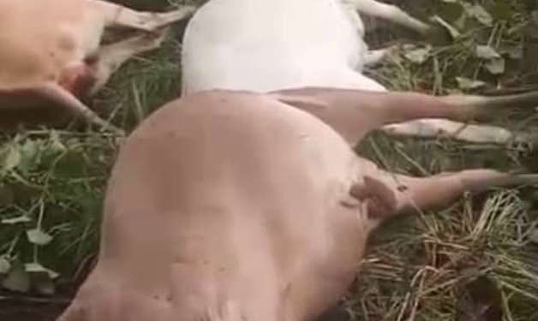](https://awokonewspaper.sl/wp-content/uploads/2024/06/Some-of-the-Dead-cattle.png)](https://awokonewspaper.sl/wp-content/uploads/2024/06/Some-of-the-Dead-cattle.png)

*By alimamy.jalloh@awokonewspaper.sl*

Freetown, SIERRA LEONE – Falaba District Livestock Officer, Joseph R. Sesay, reported on Monday that a thunderstorm struck and killed 28 cattle in the Mofindugu Chiefdom, Northern Province, Sierra Leone. The cattle, part of a herd of 645 that had crossed from Guinea into Sierra Leone, were struck on Friday night, raising concerns among locals and government officials about the safety of the meat.

***Cattle Rearers in Mofindugu Chiefdom travelled from Mali to Sierra Leone***

The cattle, originally from Mali, had entered Sierra Leone without the necessary permits. Their journey took them from Furawa and Danyoro through Mongo to the Mofindugu Chiefdom, a distance of approximately 6 to 7 miles, according to Sesay. Following the incident, the remaining cattle are under strict surveillance.

The main reason for the cattle migration, Sesay explained, was the search for greener pastures. After the thunderstorm, the matter was reported to the Ministry of Agriculture, and ongoing surveillance and diagnosis aim to ensure no diseases were imported with the cattle.

This incident is reminiscent of a similar event on September 26, 2019, in Ondo State, Nigeria, where 36 cows were killed by a lightning strike, causing fear of a potential outbreak of deadly diseases. Experts indicate that lightning strikes occur 1.5 billion times a year and are shifting away from the equator due to global warming.

Chernor Barrie, National Chairman of the Sierra Leone Livestock Rearers Producing and Marketing Organization, confirmed the cattle deaths. He noted that the cattle likely entered Sierra Leone through the Kisidougou area or other border routes without proper permits. Barrie emphasized that while the thunderstorm struck the cattle, it should not affect consumers unless the cattle were already diseased.

Bockarie Marah, a conservation activist with the Africa Conservation Initiative, verified the incident, having seen the video on social media. He explained that lightning can kill both cattle and humans through its magnetic shock if they are not protected.

Local residents in Kabala town expressed concern but had not seen any of the dead cattle or been informed about the meat being sold. The United States Centre for Disease Control advises that during thunderstorms, people should seek indoor shelter and avoid standing under trees.

The National Weather Service in the US estimates that lightning kills 20 people annually and injures hundreds more. Chairman Barrie highlighted the importance of foreign cattle for breeding and milk production, stating that their presence could boost the livestock market in Sierra Leone.

Patrick J.F. Conteh, Communications Officer of the Sierra Leone Police station in Kabala, acknowledged the incident and noted the challenges of preserving the meat due to the lack of electricity in the town.

Historical data shows similar incidents: on August 30, 2019, in Spain, 20 cows were killed by lightning, and on March 17, 2022, in Central Queensland, nine cattle were struck and killed. Experts suggest that treating cattle for thunderstorm shock involves administering non-steroidal anti-inflammatory drugs and providing general nursing care if the animals appear sore.

District Livestock Officer Joseph Sesay assured the public that the government is addressing the issue and will prevent the affected meat from reaching the market. The situation remains under close surveillance. AJ/12/6/2024