**Thunder Strikes Woman to Death in Moyamba- Sierra Leone**

<https://sierraloaded.sl/local/thunder-woman-death-moyamba/>  
  
[06 November, 2024](https://sierraloaded.sl/local/thunder-woman-death-moyamba/)   
  
Amadu Miomo

A shocking incident has left the community in mourning after a 27-year-old woman, Nyanda Gbondo, was struck and killed by lightning while working on a farm at Bondayelahun Village, Kamaje Chiefdom in Moyamba District.

The tragedy occurred around 9 PM last Thursday 31 October, 2024  as Gbondo visited a relative to collect rice harvests.

Local residents have expressed their disbelief and sorrow following the incident. The exact circumstances leading to the lightning strike remain unclear, prompting discussions about the increasing frequency of such events in the chiefdom.

Villagers noted that thunder and lightning have become more common in Kamaje Chiefdom, recalling a similar tragedy a few years prior when two individuals lost their lives to lightning strikes.

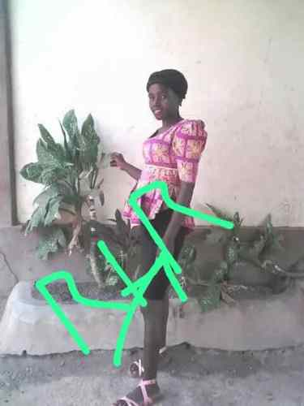

The family of Nyanda Gbondo has since laid her to rest, but the community continues to grapple with the emotional aftermath of this devastating event.

Many are calling for increased awareness and safety measures to protect against the dangers of severe weather.