Lightning data -- Strike causes deaths of seven students in Tanzania 27 Jan 2025

From: Chris Vagasky <vagasky@wisc.edu>
Sent: Wednesday, January 29, 2025 08:14
To: John Jensenius <john.jensenius@gmail.com>; Cooper, Mary Ann <macooper@uic.edu>; Katie Flanagan <katiewflanaganat@gmail.com>; Chris Schultz <cschultzwx@gmail.com>; Daile Zhang <daile.zhang@und.edu>; Donna Franklin <donna.franklin@noaa.gov>; William Roeder <roederw10@gmail.com>; Ron Holle <Rholle@earthlink.net>; Kimberly Loehr <kim@loehrlightning.com>; Chris Schultz <christopher.j.schultz@nasa.gov>; Daile Zhang <dlzhang@email.arizona.edu>; Kristin Calhoun <kristin.calhoun@noaa.gov>; Charles Woodrum <Charles.Woodrum@noaa.gov>
Subject: RE: 7 students killed, 82 injured as lightning strikes school in Tanzania

CAUTION: External Sender
Thanks for sharing, John.

The date in the story is wrong – the incident happened on the 27th rather than the 28th.

https://www.thecitizen.co.tz/tanzania/news/national/lightning-strike-kills-seven-students-injures-82-in-geita-4904142

GLD360 detected 118 events within 10 km of the school between 1:17 and 3:02 pm local time. 8 of those events were CG within 1 km of the school (marked as red dot below).

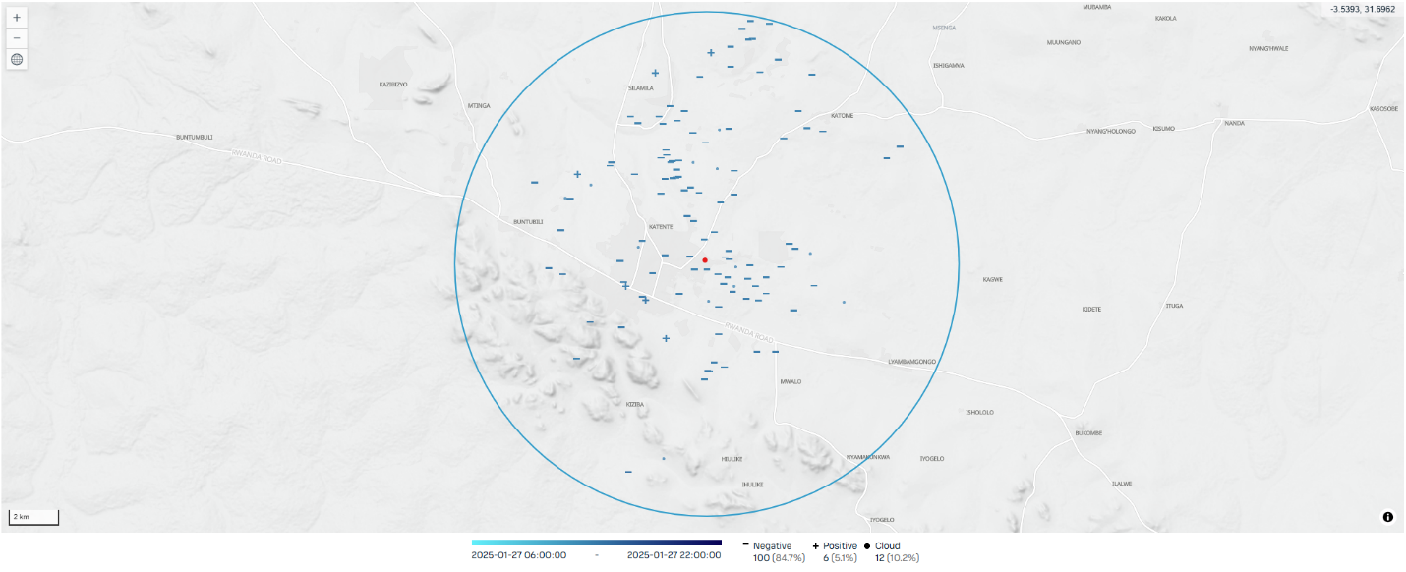

Chris

From: John Jensenius <john.jensenius@gmail.com>
Sent: Wednesday, January 29, 2025 5:03 AM
To: Mary Ann Cooper <macooper@uic.edu>; Katie Flanagan <katiewflanaganat@gmail.com>; Chris Schultz <cschultzwx@gmail.com>; Daile Zhang <daile.zhang@und.edu>; Donna Franklin <donna.franklin@noaa.gov>; Chris Vagasky <vagasky@wisc.edu>; William Roeder <roederw10@gmail.com>; Ron Holle <Rholle@earthlink.net>; Kimberly Loehr <kim@loehrlightning.com>; Chris Schultz <christopher.j.schultz@nasa.gov>; Daile Zhang <dlzhang@email.arizona.edu>; Kristin Calhoun <kristin.calhoun@noaa.gov>; Charles Woodrum <Charles.Woodrum@noaa.gov>
Subject: 7 students killed, 82 injured as lightning strikes school in Tanzania

All,

In case you hadn't seen this report.
https://www.tv47.digital/7-students-killed-82-injured-as-lightning-strikes-school-in-tanzania-85600/

John
---------

