**Lightning Strikes Claim Two Lives in Yemen, Death Toll Rises to 64**

https://en.barran.press

1 Aug 2024

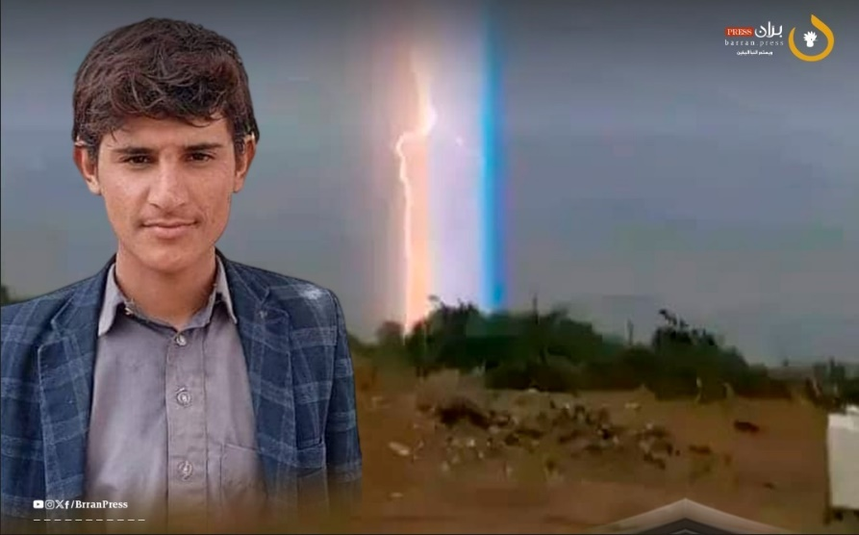

1Young man Yahya Al-Marrani died from a lightning strike in Al-Marashi, Al-Jawf (Barran Press)

Barran Press

Two individuals, a young man and a woman, have died from lightning strikes in the Yemeni governorates of Al Jawf and Marib, local sources reported on Monday, August 12, 2024. This brings the total number of casualties from lightning strikes in Yemen to 64, including fatalities and injuries, since the beginning of July.

Sources told "Barran Press" that a lightning strike hit the home of Jamil Ahmed Ghaleb Al-Asaadi in the Al-Koula area of Marib Al-Wadi district in Marib governorate, resulting in the death of Al-Asaadi and his wife.

In Al Jawf governorate, local sources informed "Barran Press" that a lightning strike killed a young man, Yahya bin Yahya Al-Jarbi Al-Marrani, in the Al-Marana district of Al-Marashi district, west of the governorate.

With the arrival of the autumn rainy season, lightning strike incidents have increased. Since the beginning of July, "Bran Press" has recorded 45 deaths, including women and children, and 17 injuries due to lightning strikes in several governorates. The total number of casualties now stands at 47 dead and 17 injured.