**Lightning kills elderly man in Kumakwane- Botswana**<https://thevoicebw.com/lightning-kills-elderly-man-in-kumakwane/> **13 November 2024** 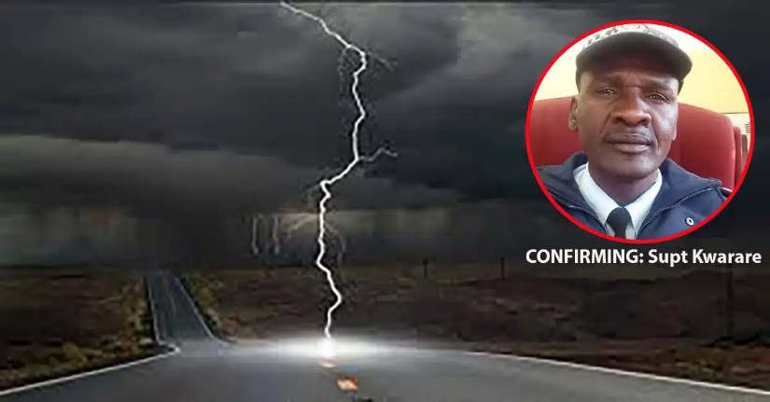

By Gofaone Koogotsitse

A 77-year-old man tragically died when a powerful lightning bolt struck his home at Botshabelo ward in Kumakwane on Sunday night.

The heartbreaking incident occurred while the elderly man, who lived alone, was sleeping in his house.

A concerned neighbour reportedly heard a thunderous crash coming from the direction of the man’s house around midnight.

In the morning when the old man was nowhere to be seen the neighbour got worried and went to check on him.

After several unanswered knocks at the door, the neighbour looked through the window and was met with a chilling sight as the elderly man lay lifelessly on his bed.

Thamaga Police Station Commander, Superintendent Moses Kwarare, confirmed the incident. “The police attended to the report and rushed the man to the hospital where he was certified dead by a medical doctor. We suspect that he was hit by lightning strike as the meter box and the bedroom lamp were also smashed,” sadly explained Superintendent Kwarare.