**Lightning kills pupil, three in critical condition in Mubende - Uganda**  
  
<https://nilepost.co.ug/news/218898/lightning-kills-pupil-three-in-critical-condition-in-mubende>  
  
01 OCT, 2024

*By* [*Fred Ssewajje*](https://nilepost.co.ug/author/Fred%20Ssewajje)

Tragedy struck Maaya Primary School in Lubimbiri Sub County, Mubende District, after lightning killed one pupil and left three others in critical condition this evening.

The victims were rushed to Mubende Regional Referral Hospital for urgent medical care.  
  
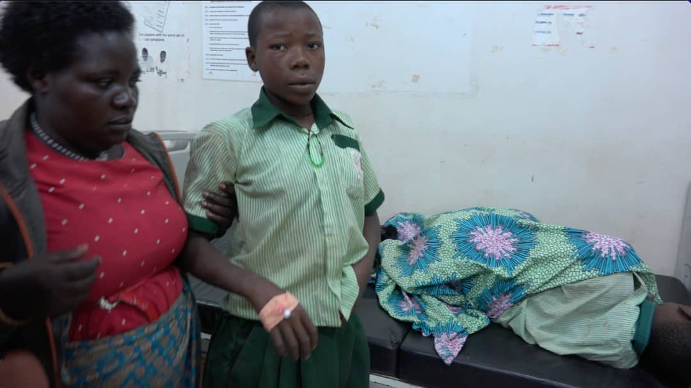

Joshua Lutegwa, the headteacher, said the lightning struck following a heavy downpour late in the evening.

“We were in a school meeting when it started raining. Suddenly, lightning struck an old block housing P5 and P6 classrooms,” Lutegwa recounted.

He added that the pupils began screaming as some of their classmates collapsed. Upon reaching the scene, they found four pupils injured.

Lutegwa identified the affected pupils as Gerald Ndyamuhaki of P.4, Metron Kamukama of P6, Rosemary Nfitundinda of P6, and Joshua Kaluhanga of P6, who tragically died on the spot.

“Kaluhanga was in a coma, but when doctors at Mubende Referral Hospital examined him, they confirmed he was already dead,” the headteacher said.

Gaad Ssebagyenzi, Chairperson of the Parents and Teachers Committee, called on the government to install lightning arresters at the school to prevent future tragedies.

"This is a government school, yet we lack basic safety measures like lightning arresters. We have lost a child, and others are in critical condition. We need urgent intervention."

Grace Nakigudde, Youth Councillor for Lubimbiri Sub County, urged parents to remain hopeful and continue praying for the recovery of the injured pupils.

"We are deeply shaken by this incident, but let us keep our children in prayer. Their condition is serious, but we trust in God for their healing," she said.

By press time, Mubende Regional Referral Hospital had not released an official update on the status of the referrals.