**Lightning Strike Kills One, Injures Three in Zombo Town Council - Uganda**

[Zombo, Uganda](https://ugandaradionetwork.net/a/archive.php?locationId=541)

**"Due to heavy rainfall today, lightning struck one of the households in my village, Cana Cell, Abira West Ward, at around 1:00 pm, burning the entire house. The mother of the family was killed instantly while she was preparing lunch for her siblings. The lightning also left her sister and two siblings unconscious," Amony explained.**

[17 Aug 2024](https://ugandaradionetwork.net/a/archive.php?statusId=4&sBefore=1723928399&sAfter=1723842000) 10:09

https://ugandaradionetwork.net/story/-lightning-strike-kills-one-injures-three-in-zombo-town-council-

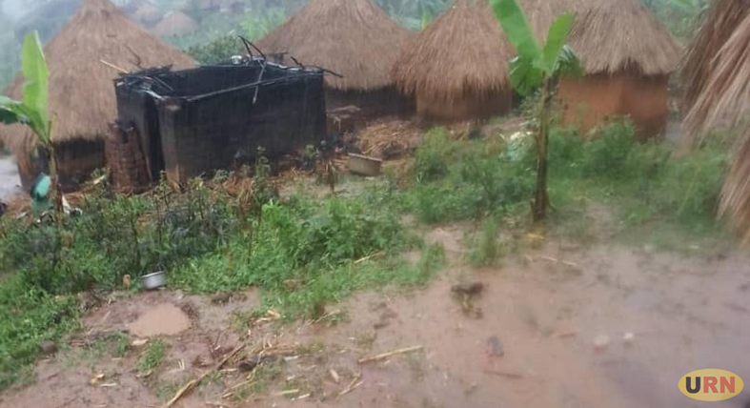

*The house set alight when lightning struck a cell in Zobo town council on 16 August. Courtesy Photo*

A lightning bolt struck buildings in Zombo Town Council, Zombo District, on Friday, August 16, 2024, killing a woman instantly and critically injuring two children and an adult mother. The incident occurred at approximately 1:00 pm during a heavy downpour.  
  
Margaret Amony, the town agent of Abira West Ward, Zombo Town Council, confirmed the tragic event. She stated that the deceased and the injured were residents of Cana Cell, Abira West Ward, Zombo Town Council.   
  
"Due to heavy rainfall today, lightning struck one of the households in my village, Cana Cell, Abira West Ward, at around 1:00 pm, burning the entire house. The mother of the family was killed instantly while she was preparing lunch for her siblings. The lightning also left her sister and two siblings unconscious," Amony explained.  
  
The lightning strike not only caused the loss of life but also set the house ablaze, destroying household properties. Residents reported that the unidentified woman was in the kitchen when the lightning struck. For weeks, Zombo District has been experiencing torrential rains accompanied by lightning and thunderstorms, which have decimated crops and properties, causing significant losses to farmers.  
  
Last July, a similar tragic incident occurred in Nebbi District, where lightning struck more than 70 primary school children who had gathered for a football competition at Oweku Primary School in Ndhew Sub-county. The children were taking shelter in classrooms during the rain when the lightning struck.  
  
During a visit to Nebbi Municipality for the connection of West Nile to the national grid, President Museveni ordered district leadership to ensure that lightning arrestors are installed in all classrooms. Local leaders report that many school buildings in West Nile still lack lightning arrestors, attributing this oversight to contractors' negligence.