**Trauma: Nebbi learners shun school after lightning attack-Uganda**

<https://www.monitor.co.ug/uganda/news/national/trauma-nebbi-learners-shun-school-after-lightning-attack-4723036>

August 12, 2024  
  
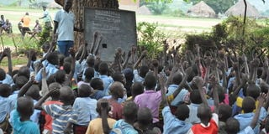

1A teacher conducting lesson for P3 class under a tree at Oweko P/7 in Ndhew sub-county, Nebbi District. PHOTO I PATRICT OKABA.

Oweko Primary School in Ndhew sub-county, Nebbi District is struggling with low attendance following a recent lightning strike that injured 79 learners about two weeks ago.

"Since the lower classes conduct their lessons under tree shades, they have developed fears of reporting back to school due to trauma," said Mr Charles Ovoya, a teacher at the school. "We are experiencing low turn up of pupils in the lower classes... We have few classrooms."

He revealed that of the 320 learners in Primary One, the number has reduced to 200 learners, primary two enrolment has reduced from 250 to 180, and P.3 enrolment has reduced from 287 to 190 learners.  
  
[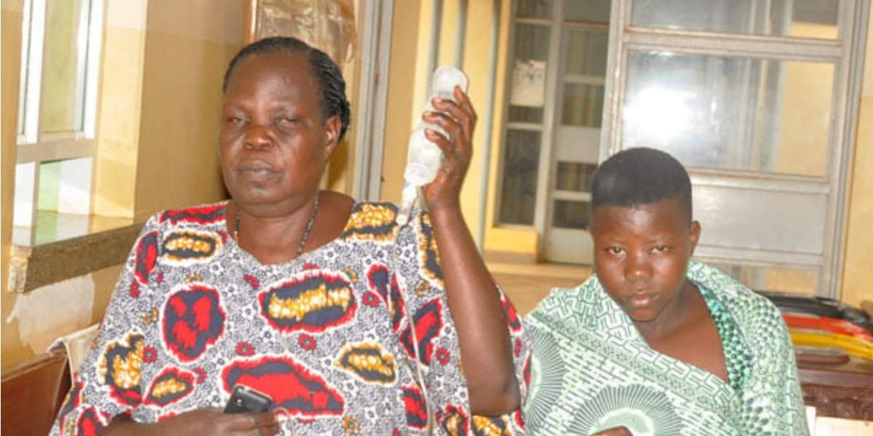](https://www.monitor.co.ug/uganda/news/national/lightning-strikes-injures-77-pupils-in-nebbi-4709034)  
  
[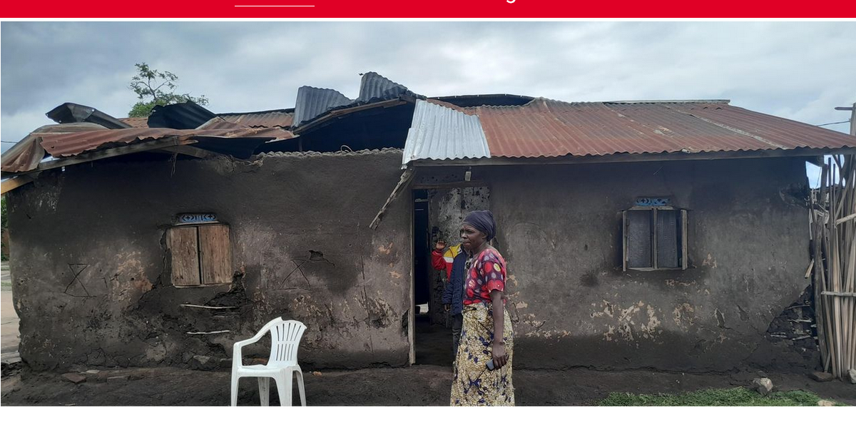](https://www.monitor.co.ug/uganda/news/national/families-left-homeless-as-hailstorm-devastates-kasese-4364910)

**Comparison**

He adds that before lightning struck the school, the total population of the learners was 1,558, but it has since reduced to 1,200.

Ms Roseline Mungu-Acel, the head teacher said on Monday that the management is incapacitated in footing bills for installing the lightning arrestors at the school and yet the school only gets Shs7 million as a capitation grant with strings attached thus making it hard to divert the money.

“We call on the government, Non-Governmental Organisations (NGOs) and Good Samaritans to assist and install the lightning arresters at our school,” she said.

The management committee is working to restore hope among the learners by sensitising them through local council structures, Village Health Teams, churches, and funeral services. 

The district inspector of schools, Mr James Gwoktho, assured that the victims are being monitored until they regain their full health.

“They are all already discharged. We shall keep on monitoring the victims until they regain their total good health conditions,” he said.

One of the learners, Ivan Rwothungeo, said they are still traumatized because when it's about to rain, almost all the learners rush home to avoid being struck again.

“If the lightning conductors are not installed, it might disrupt the learners during their national examination because PLE is normally done during rainy seasons,” he said.

Last week, President Yoweri Museveni, while in Nebbi, directed that due to the Oweko incident, the installation of lightning conductors must be a requisite for licensing in all schools.