**Tributes pour in for Hilton College learner killed by lightning strike on fishing trip - South Africa**<https://www.iol.co.za/news/south-africa/kwazulu-natal/tributes-pour-in-for-hilton-college-learner-killed-by-lightning-strike-on-fishing-trip-38cd8233-0c02-4892-8016-141fce0c41ee>  
  
4 November, 2024  
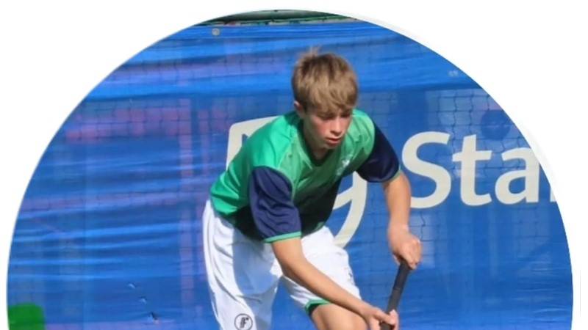

Grade 8 learner, Allan Maclean, was struck by lightning while at the Zambezi, during his half-term break. Picture: Instagram  
  
Se-Anne Rall

Tributes are pouring in for a Hilton College learner who died while on a fishing trip with his dad and friends, at the weekend.

Grade 8 learner, Allan Maclean, was struck by lightning while at the Zambezi, during his half-term break.

"Our community is in shock and deep mourning as a son has been taken too soon. Please join us in praying for Allan's family, his parents Dave and Natalie and his brother Michael as well as his Hilton friends, some of whom were with him at the time of the tragedy," said Hilton College headmaster, George Harris.

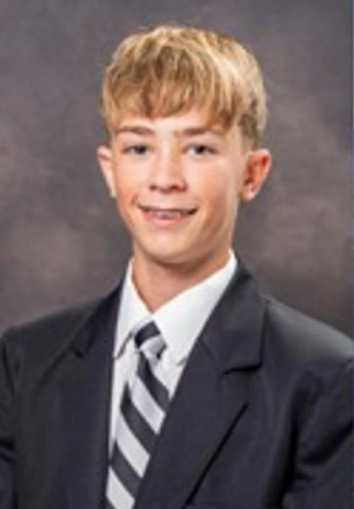  
  
*Grade 8 learner, Allan Maclean, was struck by lightning while at the Zambezi, during his half-term break. Picture: Facebook*

Tributes

“The entire Drakensberg Boys Choir School community extends most sincere condolences to the Maclean family and Hilton College. You are in thoughts and prayers at this sad and difficult time,” said Drakensberg Boys Choir.

“On behalf of the Maritzburg College family, our heartfelt sympathy and condolences go to the Maclean family and to our Hilton brothers. Our thoughts are with you all in your grieving and sadness. RIP young Allan - a life lost far too soon,” added Maritzburg College.

St. Nicholas Diocesan School expressed condolences to the family and school.

"You are in our thoughts and prayers. May God be your strength, comfort and peace during this very difficult time. Rest peacefully Allan. All our love,“ the school said.

“It is with heavy hearts that we extend our deepest sympathies to the Maclean family and the Hilton College community. The Epworth family grieves with you in this time of unimaginable loss. You are in our thoughts and prayers. May you find comfort in the shared compassion and support of those around you,” said Epworth School.

Meanwhile, a Grade 12 learner from Mbonambi Secondary School in Kwambonambi died after he was knocked by a train.

The Department of Education in KwaZulu-Natal said the South African Police Services (SAPS) and the forensic team were at the scene to retrieve the body for identification.

"Department officials visited the school where full trauma counselling support was offered to learners. On Monday the department's special needs services will monitor matric examinations and will give further support," said KZN spokesperson for the department, Muzi Mahlambi.

"I encourage learners to take all necessary precautions and safety measures at all times. As a Department we are shocked and saddened by this tragic loss of our Grade 12 learner during the third week of the National Senior Certificate Examinations.

"Our heartfelt condolences to the family, learners, and staff of Mbonambi Secondary School," added KZN MEC for Education, Sipho Hlomuka.