**Lightning Kills 70-year-old Man In Kogi Community - Nigeria**

*Posted by Amarachi on Fri 18th Oct, 2024 - tori.ng*

https://www.tori.ng/news/284790/lightning-kills-70yearold-man-in-kogi-community.html

**The incident happened at about 5:40 pm on Thursday, October 17, 2024, following a heavy downpour in the community.**

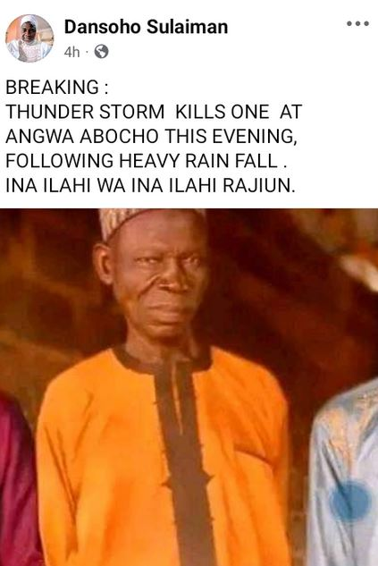

A 70-year-old man identified as Malam Abu Yusuf has been struck dead by lightning in Angwa Abocho, Dekina Local Government Area of Kogi State.  
   
The incident happened at about 5:40 pm on Thursday, October 17, 2024, following a heavy downpour in the community.  
   
It was gathered that the deceased was outside when the incident happened.  
   
He fell and died on the spot.  
   
Malam Yusuf will be laid to rest on Friday morning.