**Panic at Wedding as Lightning Strikes During Intense Moment of Prayer for Newlyweds- South Africa**  
  
<https://www.tuko.co.ke/people/572012-panic-wedding-lightning-strikes-intense-moment-prayer-newlyweds/>  
Wednesday, December 11, 2024   
  
By John Green

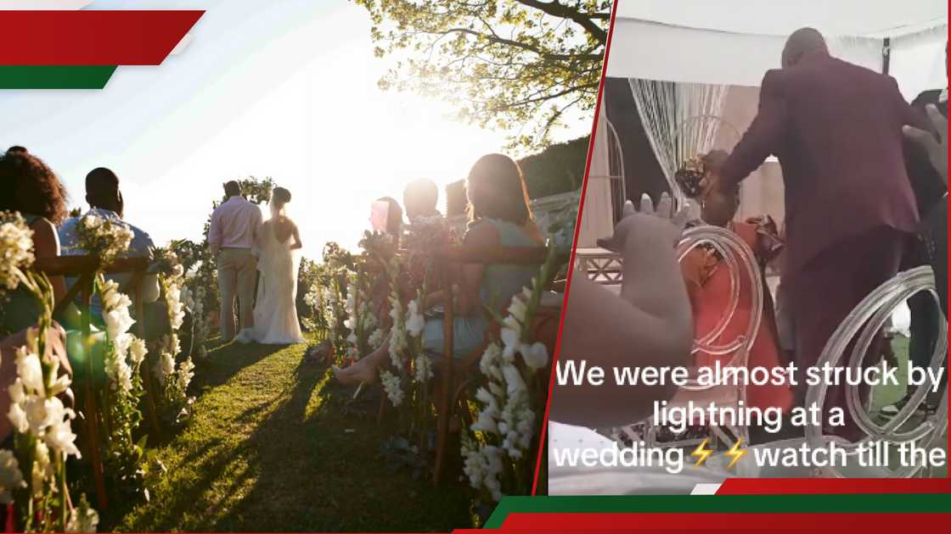  
  
Wedding taking place in the open (l). Pastor praying for newlyweds r ). Credit: fortunate_dolly, Getty Images/Klaus Vedfelt.  
Source: Getty Images

## South African couple kneels for prayers

The newlyweds knelt and bowed their heads as the [pastor](https://www.tuko.co.ke/314572-top-richest-pastors-world.html) stretched his hands to proclaim their final blessings.

There was silence as the guests listened to the powerful [prayers](https://www.tuko.co.ke/tags/prayers/) of the man of God to the adorable couple.

Thunderstorms could be heard from the background during the prayer moments.

## South African pastor's blessing to newlyweds

"I speak joy, I speak freedom, I speak everything good in their lives in the name of Jesus Christ," the pastor said as he paused momentarily.

The pastor switched from English to his native language, and lightning struck after praying for the couple's blessing for a few seconds.

Some guests bent down following the strike, but no one seemed injured by the bolt, except one man who seemed to have been affected by it.  
  
After the lightning strike, the pastor prayed briefly before checking if everyone was fine.

## Lightning strikes in church in Uganda

On Saturday, November 2, worshippers [gathered for prayers at a church](https://www.tuko.co.ke/world/africa/567749-uganda-14-killed-34-injured-lightning-strikes-church-service/) in Palabek Refugee Settlement Site were struck by lightning.

[Uganda](https://www.tuko.co.ke/tags/uganda-news/) Police Force confirmed the incident and stated they had not identified the victims.

The authorities also stated that 34 people who sustained injuries were rushed to the Paluda Health Centre III.