**Kirehe: Lightning kills 24-year-old woman, cows and sheep [Rwanda]**  
<https://www.newtimes.co.rw/article/21120/news/environment/kirehe-lightning-kills-24-year-old-woman-cows-and-sheep>

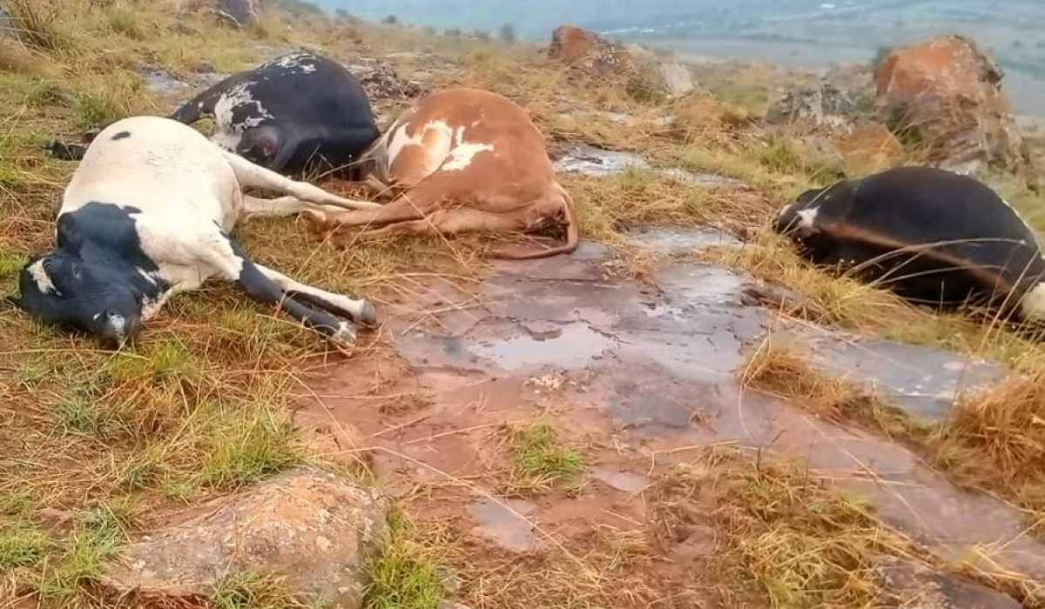

1A scene of an incident where a lightning strike clainmed the life of one person, along with eight cows and sixteen sheep, during Sunday’s heavy rain in Kirehe District on October 20, Courtesy

21 October, 2024   
  
[Emmanuel Nkangura](https://www.newtimes.co.rw/author/138/emmanuel-nkangura)   
  
A 24-year-old woman and over 20 cows and sheep died when lightening struck in Kirehe District on Sunday, October 20. The incident occurred in Remera Village, Nyarutunga Cell, Nyarubuye Sector, during heavy afternoon rains at around 7:00 p.m.

Kirehe District Mayor Bruno Rangira confirmed the tragedy, stating that: “The lightning struck one of our residents, 24-year-old Solange Murekatete, while she was at home, killing her instantly.

“In the same strike, eight cows and 16 sheep, belonging to local farmer Evariste Sindikubwabo were also killed while grazing outside.”

Following the incident, local authorities rushed to the scene in Nyarutunga, where they held a meeting with the community to offer condolences and assure them of the administration's support during the burial of the victim.

Officials were also checking whether the lost livestock had insurance coverage in order to provide further support to the affected family. The mayor urged the public to exercise caution during the rainy season.

"We advise residents to avoid seeking shelter under trees or working in exposed fields. It is also important to move livestock to secure areas, such as barns or under bridges, to prevent tragedies like this," Rangira emphasized.

This tragedy left the community shaken.

Area authorities considered measures to ensure safety measures are reinforced to prevent similar tragedies in future.