**TRAGIC LIGHTNING CLAIMS TWO LIVES IN QACHA’S NEK- Lesotho**  
<https://www.lena.gov.ls/tragic-lightning-claims-two-lives-in-qachas-nek/>  
  
13 November 2024  
  
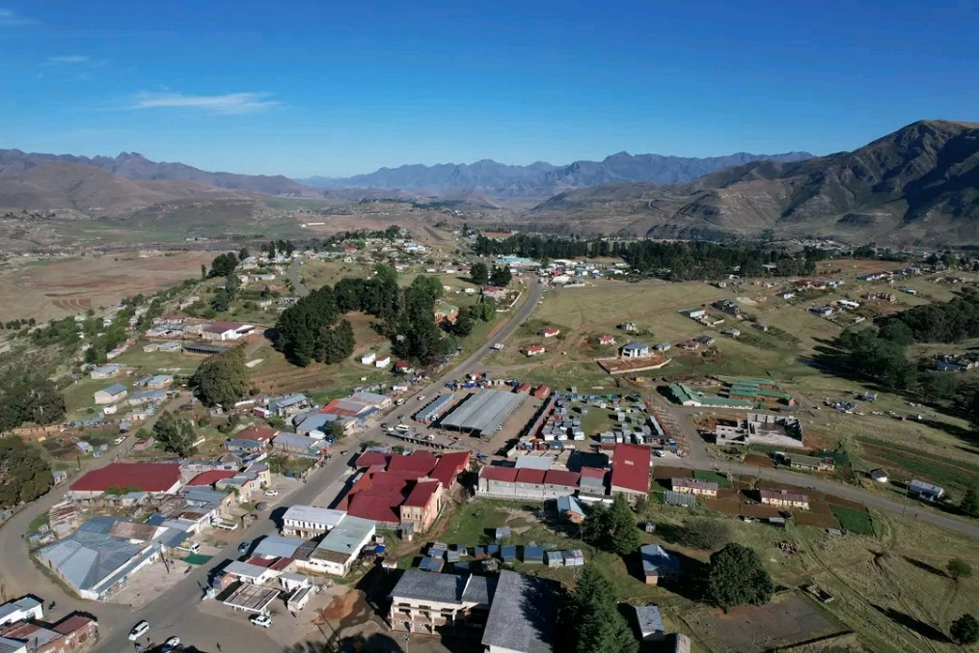

By Lena  
Qacha’sNek, Nov. 13 — A devastating tragedy unfolded in Sekiring, ’Melikane when four elders—three women and a man from Ha Thokoa were struck by lightning during a storm.

The group was on the way to a female initiation school when the lightning struck, leaving the community in shock and grief.

As they neared the village, a deafening crack of thunder shattered the silence, followed by a desperate cry for help. The villagers rushed to the scene, only to discover the horror that had unfolded: two of the victims had been killed instantly, while a third, a woman, was unconscious but later regained consciousness.

The man who survived the ordeal is still recovering from the traumatic experience.