Woman Killled by Lightning, along with 8 Cows and 16 Sheep in Remera Village [Rwanda]
https://mobile.igihe.com/amakuru/u-rwanda/article/inkuba-yishe-umuntu-umwe-n-amatungo-24-i-kirehe
This Sunday, 20th October 2024 during the heavy rain of that afternoon, lightning killed unnamed woman, aged 24, and also killed 8 cows ,and 16 sheeps. This tragedy occured in Remera Village, Nyarutunga Cell, Nyarubuye Sector, Kirehe District, within the Eastern Province of Rwanda. Mr Bruno Rangira, the Mayor of Kirehe District confirmed this report.
-----
Inkuba yishe umuntu umwe n’amatungo 24 i Kirehe
20-10-2024 - saa 19:01, Hakizimana Jean Paul
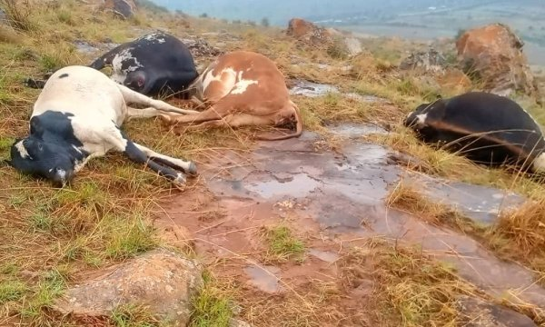
Inkuba yishe umuntu umwe n’amatungo 24 i Kirehe
Inkuba yishe umuturage umwe wo mu Karere ka Karere ka Kirehe, inica amatungo 24 arimo inka umunani n’intama 16, ubuyobozi bwongera gusaba abaturage kwirinda kugama munsi y’ibiti no gushyira imbaraga mu kororera mu biraro mu kwirinda ibyakwangiza amatungo yabo.
Iyi nkuba yishe uyu muturage kuri iki Cyumweru tariki ya 20 Ukwakira 2024 mu Mudugudu wa Remera mu Kagari ka Nyarutunga mu Murenge wa Nyarubuye, ahagana saa Saba z’amanywa ubwo hagwaga imvura nyinshi.
Umuyobozi w’Akarere ka Kirehe, Rangira Bruno, yabwiye IGIHE ko iyi mvura yishe umuturage umwe n’amatungo 24 arimo inka umunani n’intama 16 zose zo mu Kagari kamwe.
Yagize ati “Umuntu umwe niwe wapfuye yari Umugore w’imyaka 24 ariko muri ako kagari ka Nyarutunga inkuba yanakubise amatungo arimo inka 8 n’intama 16. Aya matungo yari ari mu rwuri aho uwo muturage asanzwe ayororera.”
Meya Rangira yakomeje avuga ko bahise bajya muri ako Kagari gukorana inama n’abaturage kugira ngo babahumurize banabamenyeshe ko ubuyobozi buri kumwe nabo yaba mu gushyingura uwo muturage bapfushije.
Banaboneyeho kandi kwihanganisha umuturage wapfushije amatungo, bakazasigara bareba niba yari ari mu bwishingizi kugira ngo ashumbushwe.
Abaturage basabwe ko muri iki gihe cy’imvura birinda kugama munsi y’ibiti cyangwa se mu mirima baba bari guhingamo. Basabwe kandi ko amatungo bajya bayororera mu biraro mu rwego rwo kwirinda ko yakubitwa n’inkuba cyangwa se akaba yahura n’ibindi byago bitandukanye.

-----

Report by email from Frank Shumbusho at tct2020@gmail.com.

