**14 people killed, 34 injured as lightning strikes church -Uganda**

<https://www.tv47.digital/14-people-killed-34-injured-as-lightning-strikes-church-76117/>  
  
November 3, 2024  
  
By [TV47 Kenya](https://www.tv47.digital/author/tv47_kenya/)

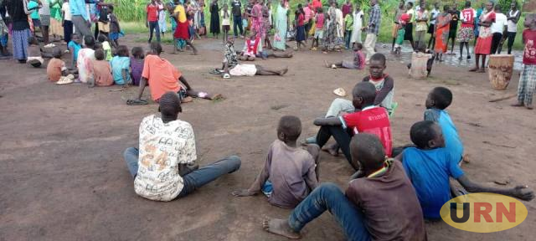  
Fourteen people were killed and 34 others seriously injured on Saturday November 2, 2024 after lightning struck a church in Lamwo District, Northern Uganda.

According to Uganda’s police spokesperson Kituuma Rusoke, the incident occurred at around 5:30p.m when the victims had gathered for a prayer service.

“The incident happened during a prayer service at a church in Zone 8, Block 2. in Palabek settlement camp,” Rusoke noted in a statement on Sunday.

“The victims, yet to be identified, had gathered for prayers when the rain started around 5:00 p.m., and the lightning thunder struck (sic) at 5:30 p.m,” he added.

The church is located at the Palabek refugee camp.

In June 2024, a similar incident happened at a school in the Northern Nebbi District, when 77 pupils were injured.

The pupils from different schools were playing in an open field during a games competition when they were struck by lightning.