**Lightning strike kills 34 Cattle in Matimba Village, Mchinji- Malawi**  
  
<https://www.maravipost.com/lightning-strike-kills-34-cattle-in-matimba-village-mchinji/?amp=1>  
November 21, 2024

By [Burnett Munthali](https://www.maravipost.com/author/bmunthali/?amp=1)

[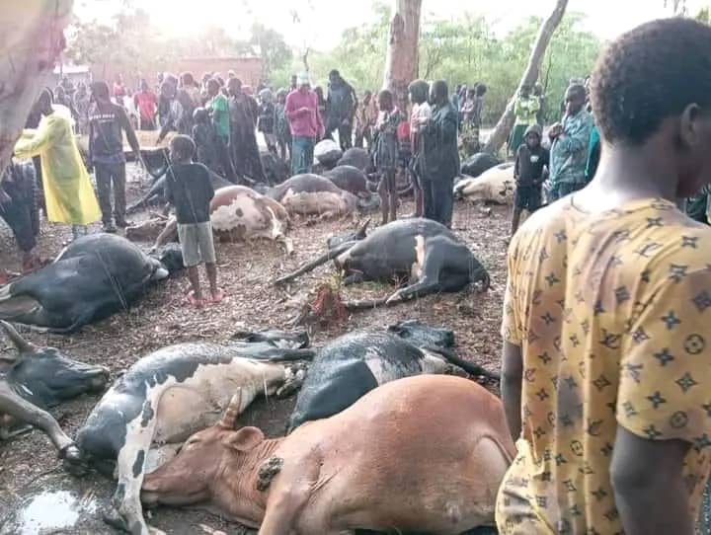](https://www.maravipost.com/wp-content/uploads/2024/11/cows-dead.jpeg)  
*Lightning strike kills 34 Cattle in Matimba village, Mchinji*

Lightning strike kills 34 Cattle in Matimba Village, Mchinji

By Burnett Munthali

A lightning strike has killed 34 cattle in a single incident today in Matimba Village, under Traditional Authority Simphasi in Mchinji District.

One of the owners of the deceased cattle, Mikson Josephy, explained that the lightning struck the animals as they were gathered under trees during rainfall.

“The tragedy occurred while the herder had stepped away to secure some cattle in their pens. All the affected cattle were part of a group of approximately 45 animals,” said Josephy.

When Zodiak reporters arrived at the scene, livestock owners were already removing the dead animals, frustrated by delays from veterinary officials who had promised to arrive for inspections.

This incident has left a devastating impact on the affected farmers, who depend heavily on their livestock for their livelihood. Local authorities are yet to comment on whether compensation or support will be provided.