**Lightning Kills P3 Pupil, Injures Six Others in Kassanda-Uganda**

<https://nilepost.co.ug/news/226029/lightning-kills-p6-pupil-injures-six-others-in-kassanda>  
  
09 November, 2024

At least one pupil was killed and six others sustained injuries when lightning struck their classroom during a downpour on Friday   
  
By Catherine Namugerwa

A tragic lightning strike hit Kalwana Primary School in Kassanda District yesterday, claiming the life of a 14-year-old pupil and injuring six others.

The incident occurred during an afternoon downpour, with lightning striking a Primary Three classroom through a window.

The deceased, Jackline Namawejje, was a Primary Three pupil and the daughter of Baker Mawejje from Mpologoma LC1, Lwangiri Parish, Kalwana Sub County.

Six other pupils sustained injuries and were taken to Lwanjiri Health Center III and Kassanda Health Centre for treatment.

Among the injured are:

* Joan Nabankema, 14, Primary Three pupil
* Mary Navuga, 13, Primary Four pupil
* Roden Ntuuyo, 13, Primary Three pupil
* Prossy Nalubega, 13, Primary Three pupil
* Scovia Namaganda, 10, Primary Three pupil
* Sarah Naiga, 13, Primary Three pupil

A medical professional at Lwanjiri Health Center III confirmed receiving three pupils in critical condition; sadly, Jackline Namawejje did not survive, though the other two are now stable.

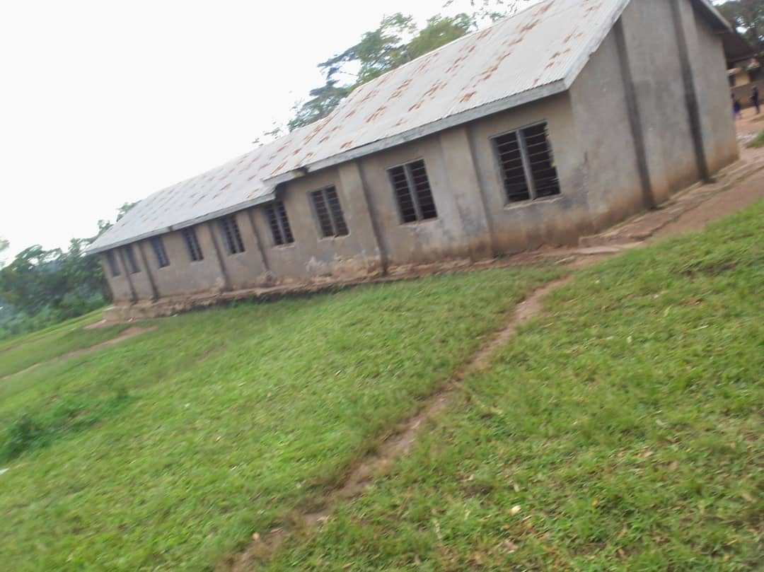

The window through which the lightning struck the P6 classroom/ Catherine Namugerwa

Abdul Lukooya Ssekabira, the district education officer, stated that Kassanda District lacks sufficient funds to install lightning arresters in all schools, though some have been equipped.

SP Racheal Kawala, police spokesperson for the Wamala Region, confirmed the incident, noting that a postmortem had been conducted and the body handed over to the family.

This is not the first time lightning has struck in this area, with previous incidents resulting in fatalities.

In the past two weeks, Kassanda District has mourned the loss of three primary school pupils who were P7 candidates.