# Lightning strike claims life of six-year-old in KZN- South Africa <https://www.iol.co.za/news/lightning-strike-claims-life-of-six-year-old-in-kzn-5e41003c-0d6b-4f26-a271-0c118eff58d4> 7 January 2025 By Thobeka Ngema

A six-year-old boy died after he was struck by lightning and suffered severe head injuries when a rondavel house caught fire and collapsed on the 12-member family gathered to mourn a senior family member’s death.

It is believed the incident happened over the weekend.

UMlalazi Municipality spokesperson Nonhlanhla Jele said persistent inclement weather claimed Banele Mpungose’s life from the Mpofu area under the uMlalazi Municipality.

The Sishi family said a torn roof pole piece lodged itself into Banele’s head, causing an open wound. He died while being taken to hospital. Two other victims are currently receiving medical attention in the hospital.

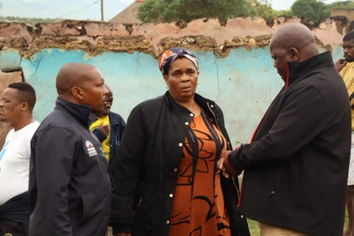uMlalazi *Municipality Mayor Queen Xulu (centre) visited the Sishi family following the tragedy. | Supplied*

uMlalazi Mayor Queen Xulu extended condolences to the Sishi family and urged residents to exercise extreme caution, as the area is prone to natural disasters.

She also pledged to assist affected families in various wards under uMlalazi.

Residents were advised to take necessary precautions, including avoiding travelling unless it is necessary.

Jele said the severe weather is expected to persist until Wednesday, with forecasts indicating a high likelihood of disruptive rainfall, causing potential flooding and damage to property and infrastructure.

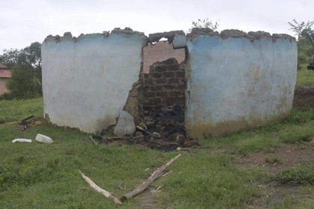  
*Banele Mpungose died after a torn roof pole piece lodged itself into his head, causing a severe open wound. | Supplied*

For Tuesday, the South African Weather Service (SAWS) issued two severe weather alerts for KZN. An Orange level 5 for disruptive rain leading to flooding of roads and settlements (formal and informal), danger to life due to fast-flowing streams, damage to property, infrastructure and loss of livelihood and livestock is expected over Zululand and uMkhanyakude districts.

A Yellow level 4, also for disruptive rain leading to flooding roads, settlements and damage to infrastructure is expected in the northern parts of KZN and the highveld of Mpumalanga.

Following the storms that caused power outages in KZN, Eskom in the province said technicians have been working tirelessly to repair faults that disrupted power supply in several parts of KZN.

“While bulk power supply to all affected areas has been restored, there may still be isolated faults in some locations,” Eskom KZN spokesperson Joyce Zingoni said.

She said the power entity apologises for the inconvenience caused by these outages and thanked customers for their patience and understanding

Zingoni encouraged customers whose power supply has not yet been restored to log a fault using any of Eskom’s available self-help channels:

The Ndwedwe Local Municipality said recent inclement weather caused significant damage when houses were washed away, bridges were flooded and it was difficult to drive on the road.

“These rains caused damage on roads leading up to Nhlangakazi and Khenana in Ndwedwe where the Shembe Church ascends during this time of the year,” the municipality said.

“This has made it difficult for the Ndwedwe Municipality to provide aid on the mountains.”

The municipality said Mayor Councillor Sam Mfeka appealed to the community and the Shembe Church to be patient during this time and when the rain stops, the municipality will bring aid to those who use these roads.

“Road D1605 heading to Nhlangakazi is affected as well as Road P714 which goes up to Khenana. The community is urged to use Road D2490 from Bhamshela,” the municipality added.

Additionally, iLembe Water Services alerted the Ndwedwe community about an interruption in water supply because of mud caused by heavy rains at a dam in Nsuze.

“iLembe District Municipality is trying to fix it, we urge the community to be patient,” iLembe Water Services said.

“The areas that will be affected by water supply are the following: wards 2, 4, 5, 6, 7 and 8.”

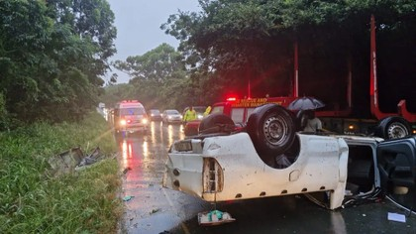Two people were *killed in separate accidents in KwaZulu-Natal during inclement weather on Monday. | IPSS Medical Rescue*

Meanwhile, on Monday, IPSS Medical Rescue’s Kelsey-Jae Meyrick urged motorists to exercise caution when driving in this inclement weather and delay any travel as much as possible until the weather clears after two people were killed in separate accidents.

Meyrick said IPSS Medical Rescue received reports of multiple motor vehicle accidents during the day.

“Sadly, two people died in separate accidents whilst multiple others sustained injuries ranging from moderate to minor.”

**thobeka.ngema@inl.co.za**