# Rwanda's lightning hotspots: Why some areas are more prone to strikes - Rwanda <https://www.newtimes.co.rw/article/23410/news/environment/rwandas-lightning-hotspots-why-some-areas-are-more-prone-to-strikes> 21 January, 2025 By [Linda M. Kagire](https://www.newtimes.co.rw/author/51/linda-m-kagire" \o "Linda M. Kagire)

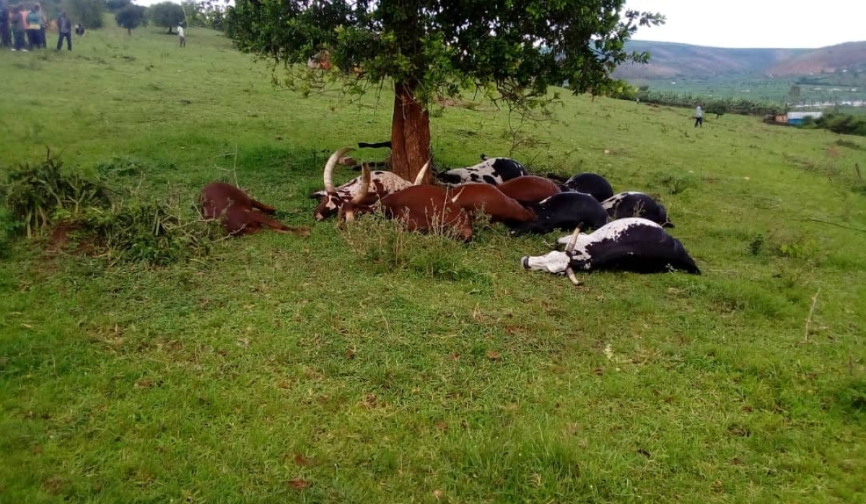  
Some cows struck by lightning in Nyagatare in 2021. Courtesy.

Every year, lightning incidents claim lives in Rwanda, particularly in the Western and Northern Provinces during rainy seasons. These areas face recurrent tragedies, with certain districts bearing the brunt.

Last week, in Rutsiro District, Solange Imanizabayo, 29, a mother of two, including a nine-month-old baby, was struck by lightning but miraculously survived in Kavumu Cell, Ruhango Sector, of the Western Province.

Imanizabayo, who left behind another seven-year-old, was coming from family errands when rain caught her in Nyundo village where she sought shelter in a nearby home, only to be struck and killed by lightning during a downpour.

The same day in the same district, lightning struck Christine Mugwaneza, 17, and Emerance, Uwizeyimana 25, but luckily, they survived and were admitted in Kayove Health Center for medical care.

Imanizabayo’s body was taken to Murunda Hospital, while her children were handed over by authorities to their grandmother.

Earlier this month, on January 5, [lightning struck at least 12 people in Mubuga Cell](https://www.newtimes.co.rw/article/23059/news/environment/lightning-strike-kills-four-injures-eight-in-karongi" \o "https://www.newtimes.co.rw/article/23059/news/environment/lightning-strike-kills-four-injures-eight-in-karongi), Murambi Sector, Karongi District, four of whom died and eight others admitted in a local hospital for treatment.

The development was confirmed by the district mayor Gerald Muzungu, who told the media that the victims, who included children, were sheltering in an unfinished house.

Similarly, last year in October, lightning struck and killed three children in Nyabikenke Cell, Bumbogo Sector, in Gasabo District during a heavy downpour on October 23.

Their mother, who had gone to a neighbour’s house to pick up something, returned to the bodies of her nine-, six- and three-year-old children who had just been struck by lightning, which also struck a nearby power transformer.

These are just some of the few cases. Every year, lightning incidents are reported mostly in Rutsiro, Karongi and Ngororero districts of the Western Province as well as Musanze and Nyabihu in Northern Province.

In the Eastern Province, [lighting cases are often reported in Kirehe and Ngoma Districts](https://www.newtimes.co.rw/article/21120/news/environment/kirehe-lightning-kills-24-year-old-woman-cows-and-sheep" \o "https://www.newtimes.co.rw/article/21120/news/environment/kirehe-lightning-kills-24-year-old-woman-cows-and-sheep). But why is lighting and thunder prominent in some parts of the country and not others?

According to Aimable Gahigi, Director General, Rwanda Meteo, lightning is less common in some parts of the country than others, for a number of reasons, the main one being the country's topography and terrain.

“Lightning is very common in certain parts of the country because of the topographic nature of those areas. For instance, [Western Province is a mountainous area](https://www.newtimes.co.rw/article/16042/news/environment/disasters-western-province-put-on-alert-over-climate-resilience" \o "https://www.newtimes.co.rw/article/16042/news/environment/disasters-western-province-put-on-alert-over-climate-resilience), where formation of cumulonimbus, also known as thundery clouds, is very common,” explains Gahigi.

Those clouds are responsible for the build-up of opposite charges during a [storm](https://www.newtimes.co.rw/article/11566/news/environment/strong-wind-destroys-100-houses" \o "https://www.newtimes.co.rw/article/11566/news/environment/strong-wind-destroys-100-houses), which poses a risk for people and animals inhabiting those hilly or mountainous areas.

The raised ground brings people, animals, trees and other electricity conductors closer to the charged and dangerous clouds.

For starters, lightning occurs when opposite charges in a storm cloud build up and break down the air's insulating capacity, which causes a rapid discharge of electricity, or lightning, which can harm or burn anything caught in the action.

“Lightning originates from a cloud called cumulonimbus cloud which normally contains high perceptible water content with upward and downward movement of air,” Gahigi said.

“The upward and downward movement of air usually contains positive and negative charges which collide and produce sparks or lightning, and sound, what we know as thunder,” he adds.

Gahigi says that cumulonimbus clouds are common in mountainous areas, which is why lighting is more frequent in Western and Northern parts of the country.

**Can one predict when it strikes?**

Every year, especially as the rainy season approaches, the Rwanda Meteorology Agency warns of lightning strikes during the rainy season, urging people to take caution and avoid things that can increase chances of being struck by lightning.

“Lightning is predictable because it is associated with the formation of rainfall. We normally have two rainfall seasons in the country namely; March to May and September to December,”

“The seasonal rainfall is sometimes associated with heavy rainfall and thunder clouds. Forecasting of lightning is possible but more accurate in a shorter period than in a longer period of time,” Gahigi says.

Gahigi further said that there are certain measures and guidelines which have been put in place by the [Ministry of Emergency Management](https://www.newtimes.co.rw/article/16464/news/environment/49-people-lose-lives-as-rwanda-records-300-disaster-cases-in-two-months" \o "https://www.newtimes.co.rw/article/16464/news/environment/49-people-lose-lives-as-rwanda-records-300-disaster-cases-in-two-months) (MINEMA), which if observed, can minimise the impact of lightning, which is a force of nature and can be complicated to predict.

He pointed out that in most places which are prone to lightning, lightning arrestors have been installed, while people are also encouraged to add lightning rods on their houses.

In Rutsiro district, Dative Kayitesi, the district mayor, said lightning protection has been installed in most public buildings, including schools, hospitals and churches, among other places.

"Since this year began, there has been only one person who was killed by lightning and last year we had about two. We haven't had many fatalities related to lightning in the past two years. As you might know, Rutsiro district was prone to lightning. We have taken some measures, including installing lightning arresters on all public buildings,"

"We certainly don’t have enough resources to cover all citizens, so we also do public awareness, encouraging people not to seek shelter in areas that are prone to lightning, such as under the tree when it is raining or electrical installations and other facilities that can attract lightning, urging school children not to play in rain," Kayitesi said.

Kayitesi said that the number of deaths caused by lightning have been reduced tremendously, ever since the measures were taken, compared to five years before, which shows that the preventive measures work, regardless of the exposure citizens still face, due to the high altitude of the district.

Experts say lightning is more likely to occur in regions with higher altitudes, where there are more clouds, which is why Rwanda's hilly topography makes some parts of the country more prone to lightning strikes than others.

Apart from the hilly landscape, other factors that contribute to lightning incidents include communication towers and other network infrastructure, which are often located on hills and in mountainous areas, making them particularly susceptible to lightning strikes.

In such cases, experts say lightning protection is essential to safeguard people and their properties from imminent lightning strikes.

The government also works with international agencies, including the United Nations agencies, to predict and minimise possible impact of lightning, which is among common disasters.

**Cultural beliefs and traditions**

The lightning phenomenon is not a new one. For centuries, Rwandans have harboured beliefs and traditions linked to lightning and thunder, some linking it to curses or witchcraft.

Eugene Munyarukumbuzi, a veteran science and geography teacher, who was born in Rutsiro district but currently lives in Kigali, says that there are many myths related to lightning and thunder, many of which are not scientifically founded.

“Because lightning strikes really quick, many people don’t really understand what happens in that moment. So, you find many stories attached to thunder and lightning,”

“Growing up, we would hear stories that it appeared in the form of an animal, a rooster or sheep, while in some cases we would hear that it struck when there was no rain at all, which many people linked to witchcraft,” explains the 62-year-old.

In other cases, it was a taboo to talk about it especially during rain while parents would also tell children to sit inside the house and switch off everything electrical, including battery powered radios at the time.

Munyarukumbuzi explains that whenever lightning struck, certain rituals, known as ‘Kugangahura’, would be performed on animals and people, to cleanse or chase the curse away.