# Lightning strike kills four cows in Kisoro - Uganda <https://nilepost.co.ug/uganda%20investment%20authority/243166/lightning-strike-kills-four-cows-in-kisoro> 16 Febraury, 2025

By Julius Kitone

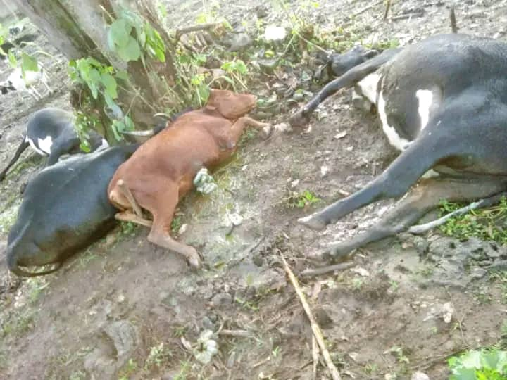

Four cows died on the spot when lighting struck  Burungu village, Muramba sub-county in Kisoro district.

The incident occurred at approximately 5 p.m when the cows were grazing near Muramba Primary School.

The cows, three of which belonged to Munezero Vincent from Kanyenka village, and one to Mr. Irimaso left the owners   distressed by the loss .

One of them collapsed and had to be rushed to the hospital for medical attention.

He is still in a state of shock and struggling to cope with the devastating blow.

“This is a big loss for me and the community. These cows were my livelihood,” Munezero said.

The incident has not only left him heartbroken but has also put a strain on his family’s ability to sustain themselves.

The strike has raised concerns among local farmers about the dangers of lightning, particularly during the rainy season.

Authorities have advised farmers to take extra precautions to protect their livestock from such natural hazards.