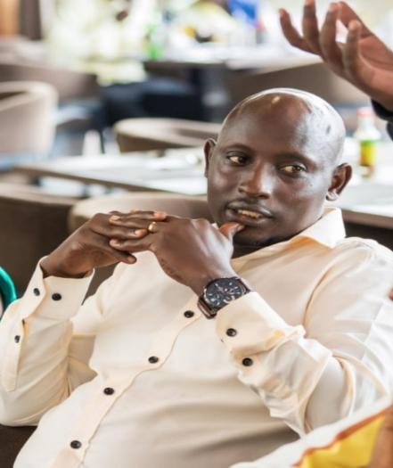

**HERO of the MONTH**

**Mwesigwa Enoth Sabiiti**

1. **What is your name and background?**

My background is in Social Works and Social Administration. I started working life as a Revenue Collector (Uganda Revenue Authority) later I join the Clearing and forwarding, I hold Bachelor of Social Works and Social Administration from Bugema university

1. **How and when did you hear about ACLENet**?

I discovered ACLENet through Mr. Barnabas Akantambira

1. **What motivated you to work with ACLENet?**

My motivation remains to give good services to my clients and keep advising them on the customs process and procedures.

1. **Please describe your work with ACLENet.**

Customs clearing representative in Uganda

1. **What are some of your key achievements so far with ACLENet?**

Awareness and networking

1. **How would you like to see ACLENet develop in the future?**

Partner with the government to cover the whole country and protect the areas prone to lightning.

1. **Is there anything else you would like to include – personal information,**

You can list my email and contact details. [nuweenos@gmail.com](mailto:nuweenos@gmail.com)

0772986629/0700596888

Thank you for your contribution, Mr. Enoth.