# Incredible moment jet is hit by lightning in European storm that also saw passenger plane struck by electrical bolt, forcing it to divert- Egypt

<https://www.dailymail.co.uk/news/article-14224293/Incredible-moment-jet-hit-lightning-Brussels.html>  
24 December, 2024   
  
  
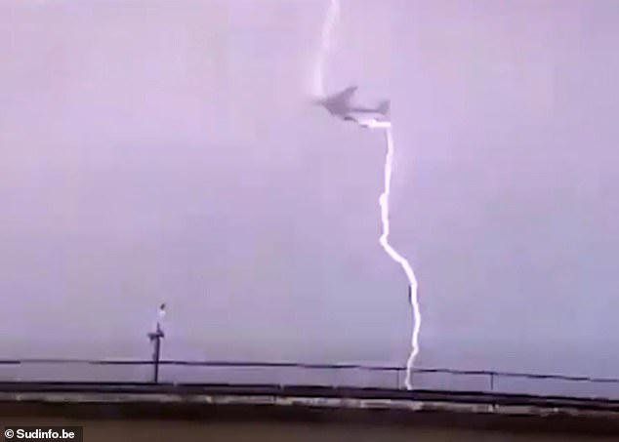  
  
*his is the terrifying moment a jet was struck by lightning shortly after takeoff in Belgium on Sunday*  
By [OLIVIA CHRISTIE](https://www.dailymail.co.uk/profile-983/olivia-christie.html)   
  
This is the terrifying moment a jet was struck by lightning shortly after takeoff in Belgium on Sunday.

A passenger plane was also struck by a huge electrical bolt in the storm, forcing the pilots to divert and abandon the flight to [Egypt](https://www.dailymail.co.uk/news/egypt/index.html" \t "_self).

The [TUI](https://www.dailymail.co.uk/news/tui/index.html" \t "_self) aircraft was travelling from Brussels Airport to the seaside resort of Hurghada when it was hit.

According to TUI spokesman Piet Demeyere, the plane returned to the airport as a precaution.

Meanwhile, dashcam footage from a car on the Brussels ring road captured the huge strike on the cargo plane bound for [Qatar](https://www.dailymail.co.uk/news/qatar/index.html" \t "_self).

The bolt of lightning appeared to travel straight through the aircraft with the impact briefly lighting up the sky.

'But despite the impact, the plane did not have to return,' a spokesperson for Brussels Airport told [Dutch](https://www.dailymail.co.uk/news/the-netherlands/index.html" \t "_self) language Belgian news site HLN.

Passengers on the TUI flight reported hearing a loud bang and a 'burning smell'.

Image shows a cargo plane taking off before it was hit by lightning on Sunday

This is the terrifying moment a jet was struck by lightning shortly after takeoff in Belgium on Sunday

One told HLN: 'We suddenly heard a loud bang, with a flash of light. Afterwards we also smelled a slight burning smell.

'It was quite a shock, with that loud bang.'

Data from aircraft tracking website FlightRadar24 shows that the plane departed Brussels at 1.35pm local time on December 22.

A map showing the flight's route shows the plane travelling in a large narrow loop before returning to the airport.

After the plane landed the passengers were taken to hotels and were boarded onto a new flight on Monday.

It comes after a British Airways plane was struck by lightning on its approach to Heathrow Airport in July.

Passengers onboard Flight BA919 from Stuttgart to Heathrow told of their 'shock' after the dramatic incident which forced crews to divert to Gatwick.

One passenger, Jeco, told The Sun: 'The crew were amazing when our flight got struck by lightning on the approach to Heathrow. It was shocking. The flight had to divert to Gatwick.'  
  
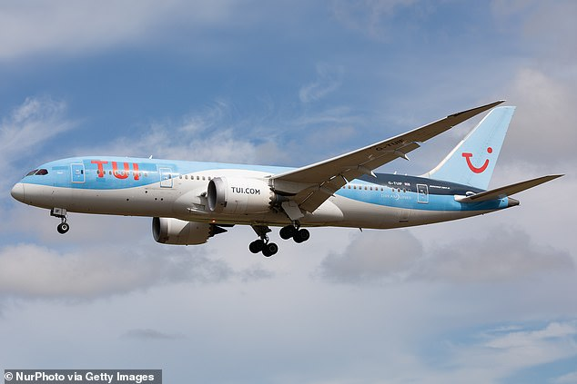

*The TUI aircraft was travelling from Brussels Airport to the seaside resort of Hurghada when it was hit (file image)*

Passenger Robert Rossall, who was returning from a trip to Germany for the Euros, praised the response by the captain and his crew, telling MailOnline: 'The captain made a decision to land at the safer airport given the conditions and lightning strike.

'Once on the tarmac he was informative and even walked the length of the plane to talk to all passengers. Cabin crew passed around bottled water and were calming. [It was] very professionally handled.'

An airline pilot previously said that lightning strikes are no more than a nuisance for aircraft and a fairly common occurrence.

Writing in his book, This Is Your Capitan Speaking, Doug Morris explains: 'Statistics show an airliner gets hit [by lightning] every 5,000 hours, or about once a year. The FAA estimates every airliner in the U.S will be struck once a year.'

He continued: 'A lightning strike can upset some of the instruments but it's not usually a really serious issue because the aircraft isn't earthed. You can have lightning going in one end and out the other and there might only be superficial damage.

'I've only experienced it once – we had a tiny hole in the nose cone and the exit point in the tail had burnt through a small piece of the tailfin support, so it had to be taken out of service.

'It was ok for a temporary flight without passengers.

'After a lightning strike, it's likely you'd need the aircraft checked over to make sure all the compasses and electronics haven't gone haywire.'