# Prayer ceremony held for students struck by lightning at Kaungwe School in Dowa- Malawi <https://malawi24.com/2024/11/30/prayer-ceremony-held-for-students-struck-by-lightning-at-kaungwe-school-in-dowa/> [Nov 30, 2024](https://malawi24.com/2024/11/) Burnett Munthali

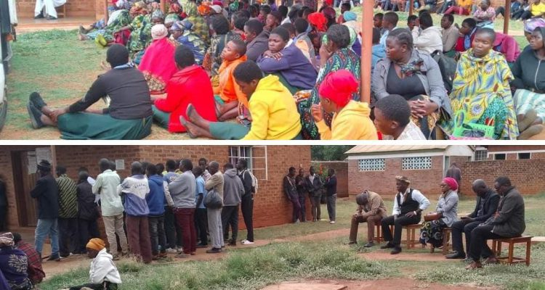

A sombre atmosphere envelops the grieving community of Mtengowanthenga in Dowa District as a prayer ceremony was held for the students who tragically lost their lives in a lightning strike yesterday at Kaungwe Primary School in Mponela.

The devastating incident claimed the lives of several students, leaving the school and surrounding community in deep mourning. Today’s ceremony aims to offer prayers for the departed souls and provide solace to the bereaved families.

The ceremony is being graced by several notable figures, reflecting the gravity of the tragedy. Among those present are members of Parliament for the Central Region constituency, Hon. Darlington Harawa, Traditional Authority Inkosi Mponela, and senior officials from the Ministry of Education.

Additionally, representatives from the Dowa District Council and other local leaders are in attendance to show their solidarity with the grieving families and community.

Speaking at the event, Hon. Harawa expressed his heartfelt condolences to the affected families and emphasized the need for unity during this difficult time. “This tragedy has shaken us all. As a community, we must come together to support these families and ensure measures are put in place to prevent similar incidents in the future,” he said.

Inkosi Mponela echoed these sentiments, urging the community to remain strong and committed to supporting one another.

This incident has reignited discussions about safety measures in schools, particularly during the rainy season. Local leaders and

[Education](about:reader?url=https://malawi24.com/2024/11/30/prayer-ceremony-held-for-students-struck-by-lightning-at-kaungwe-school-in-dowa/) authorities are calling for heightened awareness and action to protect students and teachers from natural disasters.

As prayers are offered and tributes paid, the focus remains on providing emotional and psychological support to the affected families and the entire school community. The tragedy serves as a reminder of the fragility of life and the importance of preparedness in the face of unforeseen natural events.