**[Woman in tears after husband dies, 2 kids injured following lightning strike while asleep-Tanzania](https://www.tuko.co.ke/people/family/567541-woman-tears-husband-dies-2-kids-injured-following-lighting-strike-asleep/" \t "_blank)**

<https://www.pinterest.com/pin/911767887057825942/>  
  
21 October, 2024  
  
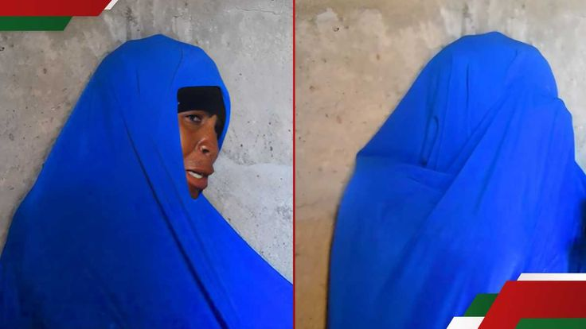

A woman, Rukia Musa has been left with the burden of caring for four young children after her husband died at home following a natural phenomenon.