# Rayo mató a un estudiante en medio de una intensa lluvia, en Quito - Algeria

**Lightning killed a student in the midst of heavy rain in Quito - Algeria**  
  
<https://www.eldiario.ec/actualidad/ecuador/rayo-mato-a-un-estudiante-en-medio-de-una-intensa-lluvia-en-quito/>

08 January 2025 - 16:06 pm  
  
Gabriela Mantuano

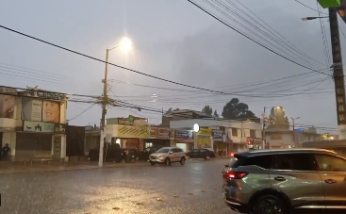

A lightning struck the death of a student in the Algeria sector, in southern [Quito](https://x.com/diariocentroec/status/1876825796028879216).

The incident was recorded on the afternoon of Tuesday, January 7, 2025 when the student was moving on a pedestrian bridge on Simon Bolivar Avenue.

At that moment [there was intense rain](https://www.eldiario.ec/actualidad/ecuador/lluvia-con-granizo-en-varios-sectores-de-cuenca/) with thunderstorms, in that and other sectors of the capital.

According to the national press, lightning struck the bridge through which the student was circulating directly affect him.

Then, inhabitants of the sector provided him with help with members of the National Police, until an ambulance arrived.

In his uniform you could see the force of the impact of the lightning.

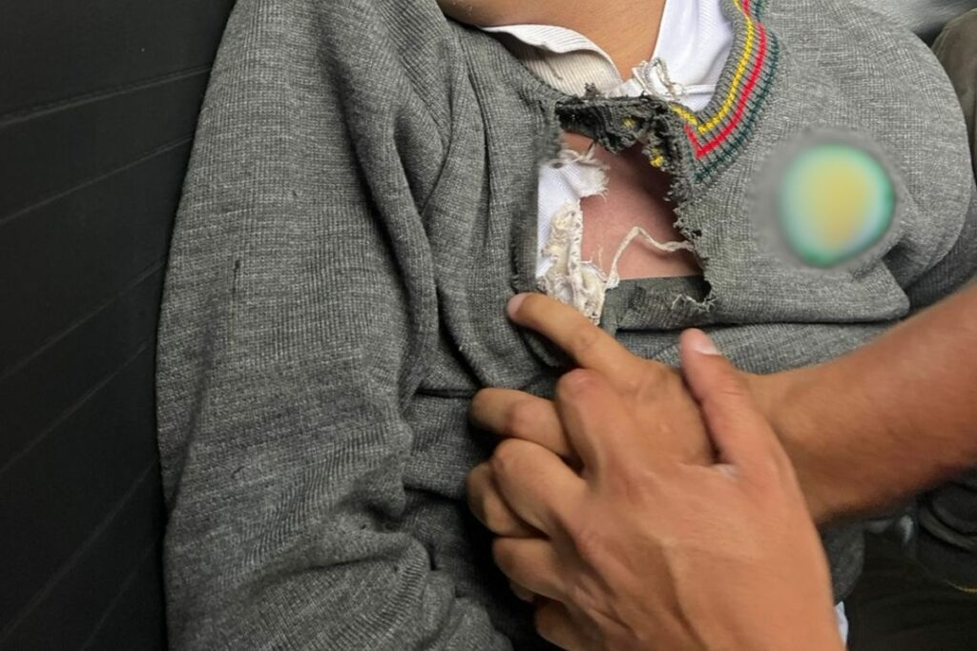

The 16-year-old was transferred to the Chimbacalle health centre, but only his death was confirmed on the site.

Through social networks, students from the Central Technical Education Unit, where the teenager was studying, expressed their regret at what happened.

According to El Comercio daily, a person passing through the site reported on Facebook that she and her baby were about to die in the middle of the electrical storm.

"I was behind the boy, we're almost struck by lightning too," the witness said.

The heavy **rain** in **Quito** generated floods in some sectors. In a mall the water accumulated in the parking lot and users had inconveniences to mobilize.