Lightning strike leaves 12 Kirinya prison inmates hospitalized - Uganda
https://www.monitor.co.ug/uganda/news/national/-lightning-strike-leaves-12-kirinya-prison-inmates-hospitalized--4902486
26 January, 2025
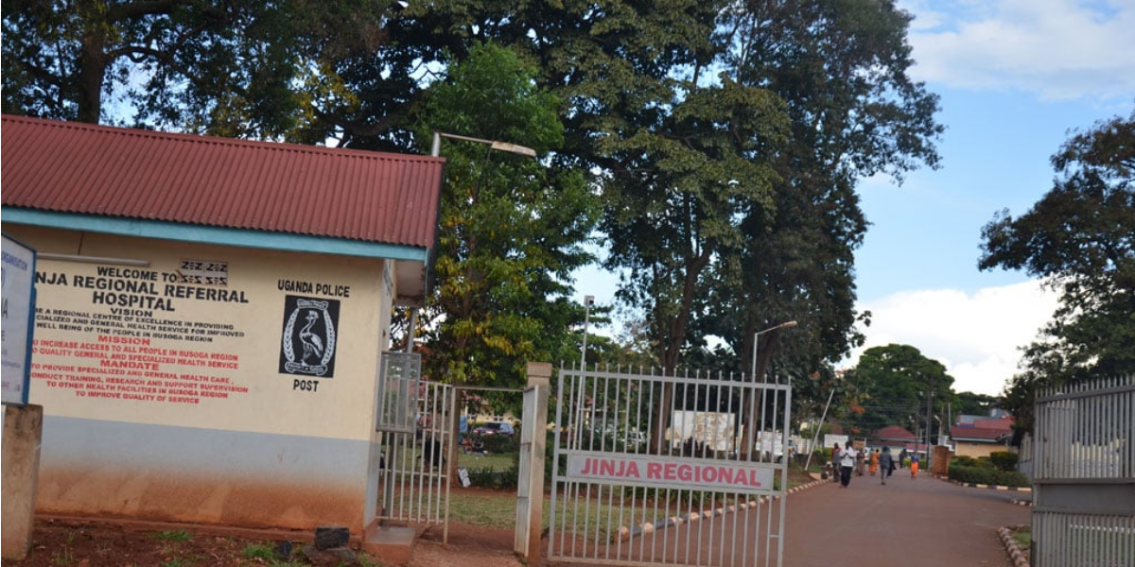
A general view of the entrance of Jinja Regional Referral Hospital, where the inmates were admitted after being struck by lightning on January 26, 2025. PHOTO/TAUSI NAKATO
By Denis Edema, Tausi Nakato
At least twelve Kirinya Prison inmates in Jinja City were hospitalized on Sunday afternoon following a lightning strike at the facility.
Uganda Prison Spokesperson Frank Baine says the twelve inmates are currently admitted at Jinja Regional Referral Hospital after the strike at around 3pm.
Baine explained that the inmates were seated under a tree when lightning struck.
“It was drizzling, and the inmates were seated under the tree in the Jinja Remand Prison. They are being managed at Jinja Regional Referral Hospital and the victims are all male,’’ Baine explained.
Baine revealed that no fatalities had been confirmed by press time Sunday evening.
Jinja Regional Referral Hospital Deputy Director Dr Afizi Kibuka confirmed to Monitor that the medical facility had “received prisoners who suffered varying degrees of burns after lightning struck them.”
However, Dr Kibuka said the victims are now under close monitoring.
“It is true, we have received victims from the prison after sustaining burns, but they are steadily responding to the treatment from the facility,’’ Dr Kibuka said.
“Three sustained serious burns while others sustained different injuries after the tree fell on them,’’ Dr Kibuka said.
Reliable sources say the victims were part of a group of inmates attending general Sunday prayers in the prison compound.

