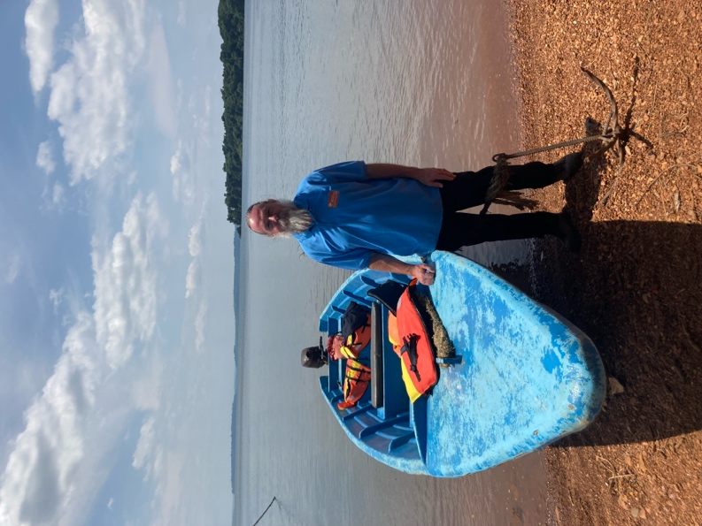**HERO of the MONTH**

**Ken Nixon**

1. **What is your background?**

I am an electrical engineer and an academic who is passionate about science, engineering, and education. I have more than 25 years of experience in these fields. One of my areas of specialization that is very close to my heart is lightning protection.

1. **How and when did you hear about ACLENet?**

I have regularly attended the International Conference on Lightning Protection (ICLP) since 1998 and naturally came to hear about ACLENet there.

1. **What motivated you to work with ACLENet?**

My principal motivation is helping people keep themselves safe from lightning.

1. **Please describe your work with ACLENet.**

I try help wherever I can, and I have assisted as a technical advisor to the lightning protection working group, and I have served as a member of the board since 2021.

1. **What are some of your key achievements so far with ACLENet?**

A particular highlight that stands out has been my trip to the Kalangala district in Uganda where I spent time on the ground working with the amazing team there, including the installation of a lightning protection system, education of learners, teachers, parents and leaders, as well as communications and outreach activities.

1. **What are some of the challenges you have encountered in your work with ACLENet? How have you addressed these challenges.**

In my experience there are two challenges. The first is that lightning safety is generally overlooked when it comes to natural disaster planning, management, and awareness. The second is the question of how we can make lightning protection systems cost-effective in resource constrained environments.

1. **How would you like to see ACLENet develop in the future?**

I would very much like to see ACLENet going from strength to strength, as well as growing roots into more countries in Africa.

1. **What do you see in the future for ACLENet regarding lightning safety?**

I see ACLENet gaining significant traction around education and awareness.

1. **Encouragement note**

I want to recognise and acknowledge the incredible support that ACLENet has received from sponsors and donors, as well as from individuals that selflessly volunteer their time and expertise – this support is invaluable. I would also like to single out the extraordinary leadership and dedication of Professor Mary Ann Cooper.

1. **Is there anything else you would like to include – personal information, family, goals, etc? Is it ok to list your email?**

LinkedIn Profile: <https://www.linkedin.com/in/kennixon>

My email address: [ken.nixon@wits.ac.za](mailto:ken.nixon@wits.ac.za)