# Four struck by lightning - Lesotho <https://www.thepost.co.ls/news/four-struck-by-lightining/> 13 January 2025 By [The Post](https://www.thepost.co.ls/author/thepostc/" \o "Posts by The Post)

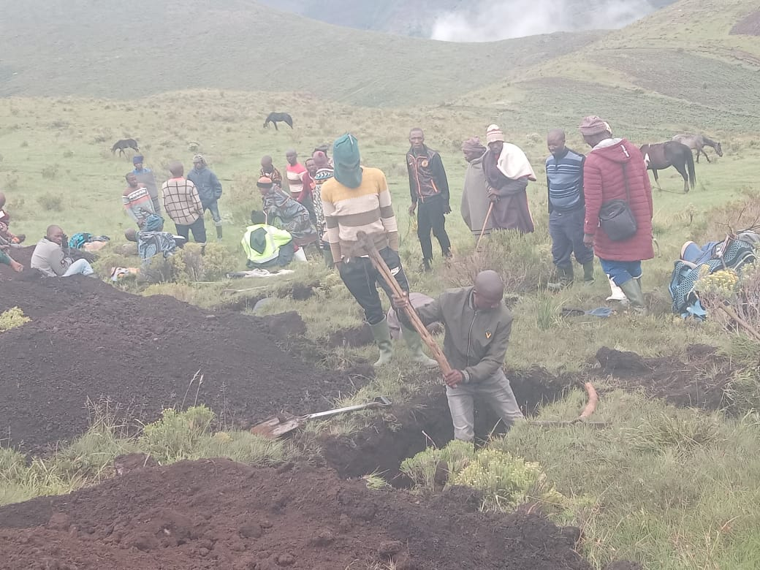

**MASERU**

FOUR men died on the spot while nine others sustained serious burns when lightning struck their hut in Sekantšing, Hloahloeng, in Mohale’s Hoek, during a traditional ceremony last Saturday.

The injured were taken to a clinic while the dead were buried on Monday.

The victims were enjoying mutton in a hut celebrating the welcoming of a baby (ho fuoa ngoana nama), a Basotho cultural rite through which ancestors are invited to guide the life of a toddler, when lightning struck.

Before the ritual is done, a Mosotho toddler is not supposed to eat meat or handled with hands not washed with fat.

Three sheep were slaughtered for the ceremony.

Unfortunately, the house the men were in was struck by lightning killing all four men.

Women were in a different hut.

“I approached one burial society that gave us coffins to bury the deceased,” Katleho Mabeleng, the Hloahloeng MP, said.

Mabeleng said they were shocked by the devastating incidents of lightning strikes in several villages within a short time.

He said a man was struck and killed by lightning in the village of Tiping on the same day, just 15 kilometres away from Sekantšing.

A few days prior to this, two other people were struck and killed by lightning in Ha-Lechesa in the same area.

Mabeleng said two houses in the villages of Ha-Nonyane and Ha-Rankhoba were also struck by lightning and caught fire a few days earlier.

“Now villagers believe that they are under attack by evil spirits,” he said.

However, Mabeleng holds a different opinion from the other villagers.

“I think this is caused by climate change,” Mabeleng said.

He said the incident has sent shock waves in the villages.

Meanwhile, our norther region reporter, ’Malimpho Majoro, reports that a 50-year-old Mokhotlong man stabbed his brother to death on suspicion that he had directed lightning to kill his wife.

High Court judge Justice Itumeleng Shale heard during the bail application that Nkareng Mokoatle believed in witchcraft.

The court heard that on December 29, 2024 Makoatle’s wife, ’Mampololeng Mokoatle, was struck by lightning in her house and died.

Mokoatle alleged that his brother, Mahloko Mokoatle, was responsible for the death of his wife as they never saw eye-to-eye.

He said sometime in December while still in his house, his brother who was a sangoma threatened him and his wife during a family squabble.

Mokoatle’s lawyer Advocate Balone Qothelo, petitioning the judge to grant him bail, said the brother had threatened that they “would see what he would do to them”.

The threat from the brother came after a long family disagreement during a meeting with Mokoatle.

On December 29, the court heard, the weather was clear but as the sun rose high there were clouds and heavy rain with thunderstorms began to fall.

“My wife was still in the house with our six-year-old child and a seven months old when the lightning struck” Mokoatle said.

The wife died on the spot while the six-year-old child was taken to hospital.

Mokoatle said he was pained by his wife’s death and immediately recalled the quarrels they had with his brother. He remembered that his brother had threatened that he would see what he would do to them.

He also said his brother bragged in the village telling villagers that he had forewarned about what would happen.

“That’s what angered me most,” he said.

He said he went to the brother’s home to confront him.

“We had a quarrel which led to a physical fight and I ended up stabbing him with a knife which I was holding,” he said.

However, Advocate Qothelo explained during the bail application that his client never intended to kill his brother.

He argued that all he wanted was to confront his brother and make peace since they were not on good terms.

“If he had an intention to kill him, he could have killed him a long time ago when he moved out of his house,” he said.

He told the court that his client was the breadwinner of the Mokoatle family and “helped almost every member of the family, including the deceased brother who was under his care”.

He said Mokoatle is employed at the Lesotho Highlands Water Project and “could never be a criminal in any manner”.

“He has already lost a wife and his brother and he is faced with raising two minor children on his own,” he said.

Justice Shale granted him bail of M2 000 with M5 000 surety on condition that he should not interfere with crown witnesses and stand trial.