# KZN weather: 11 dead, 6-year-old boy killed in lightning strike- South Africa <https://www.citizen.co.za/network-news/lnn/article/kzn-weather-11-dead-6-year-old-boy-killed-in-lightning-strike/> 9 January 2025

## An estimated R411m in damage has been caused as severe weather has already destroyed 370 homes and disrupted power supply in several areas.

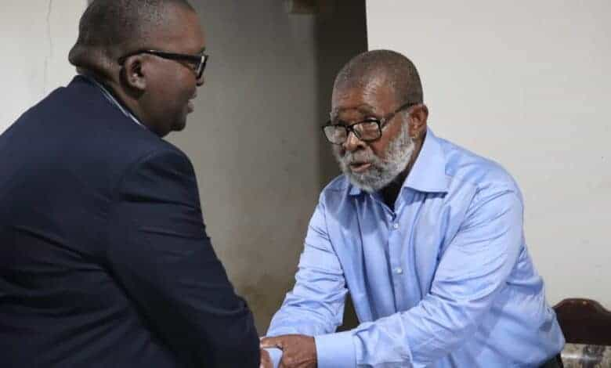  
*MEC Rev Thulasizwe Buthelezi visits Ward 15 of the Nongoma Local Municipality. Photo: Supplied*

By Kayla Shaw

The level 8 thunderstorms experienced across KZN in recent days have claimed 11 lives, including a six-year-old boy who was struck by lightning on Sunday.

[According to The Witness](https://witness.co.za/news/2025/01/08/kzn-weather-11-dead-six-year-old-boy-killed-in-lightning-strike/" \t "_blank), the province continues to grapple with the devastating aftermath of torrential storms that have caused significant damage to infrastructure, widespread power outages, and loss of life, according to the Department of Cooperative Governance and Traditional Affairs (Cogta).

Cogta MEC Thulasizwe Buthelezi expressed his deep condolences to the families of those who perished, including Banele Mpungose (6) from KwaMpofu near Eshowe and under uMlalazi Municipality, who died on Sunday.

According to uMlalazi Municipality spokesperson Nonhlanhla Jele, the boy suffered a severe head injury after a lightning strike on the house they were staying in. Twelve members of Banele’s family had gathered in the rondavel to mourn a senior member’s passing when the structure was struck by lightning, caught alight, and collapsed.

“According to the Sishi family, a torn roof pole piece lodged into Banele’s head, causing a severe open wound. Unfortunately, he succumbed to injuries while being transported to the hospital. Two other victims are currently receiving medical attention in the hospital,” Jele said.

#### Drownings

Lwandle Pasi (22) from Darnal in KwaDukuza and Siyabonga Mavundla from the Ohwebede area in Mandeni also lost their lives during the heavy storms, drowning in separate incidents on Saturday.

Cogta dispatched disaster management teams to support the affected families by providing essential resources, co-ordinating relief efforts, and assessing the extent of the damage. Buthelezi visited Ward 15 of the Nongoma Local Municipality yesterday morning, offering immediate relief to the family of Umtwana wakwaFihlinqindi kaTselendoda kaDinuzulu, whose home was severely damaged by a structural fire.

The MEC provided essential supplies, including blankets, food parcels, plastic sheeting, and an emergency box.

#### Severe weather

The severe weather has caused widespread disruption across the province, with extensive infrastructure damage. A total of 370 houses were completely destroyed, and 933 households were affected. Municipal roads, bridges, schools, and water infrastructure all bore the brunt of the storm. The cost of damages is estimated at R411m.

Several municipalities, including Cato Ridge, eMpangeni, uLundi, Msunduzi, Nquthu, Vryheid, Wartburg, Stanger, Hluhluwe, and Nkandla, have experienced large-scale power outages. Eskom technical teams are working tirelessly to restore power, according to the statement.

Buthelezi commended the swift response of social partners, relevant departments, and government agencies in addressing the incidents across the province.

Residents are urged to remain vigilant as inclement weather conditions are expected to continue. Motorists are strongly advised to exercise extreme caution on the roads due to slippery conditions.