**4 endangered mountain gorillas killed by lightning strike in Uganda, conservation groups say**

*There are just over 1,000 mountain gorillas in existence.*

By **[Morgan Winsor](https://abcnews.go.com/author/morgan_winsor)**

February 10, 2020, 10:17 AM

<https://abcnews.go.com/International/endangered-mountain-gorillas-killed-lightning-strike-uganda-conservation/story?id=68883431&cid=social_fb_abcn&fbclid=IwAR0896AKaD1-KB1gOTXy90aD335MAVstkF8tOg16MaBlpE1fn_bl40-zF1g>

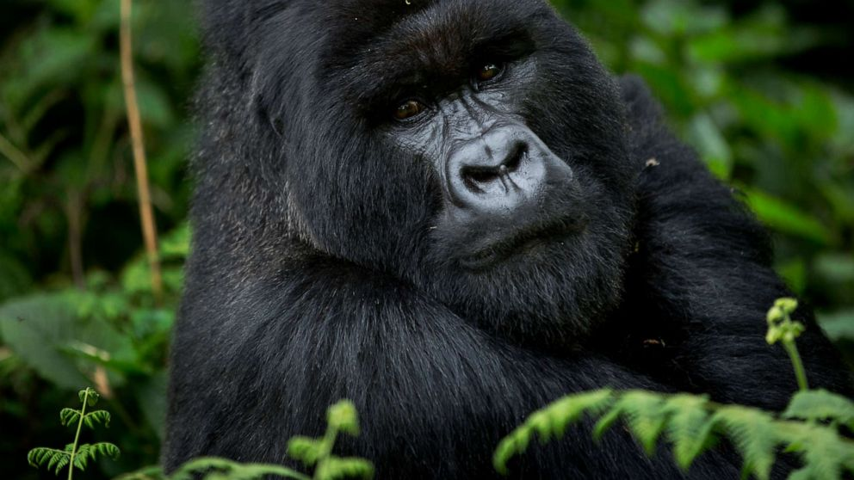

**News headlines today: Feb. 10, 2020***Catch up on the developing stories making headlines.*Ben Curtis/AP, FILE

LONDON -- Four endangered mountain [gorillas](https://abcnews.go.com/US/koko-famous-gorilla-learned-sign-language-laid-rest/story?id=56105047) have been killed by an apparent lightning strike in one of Uganda's national parks, [conservation groups](https://abcnews.go.com/International/lions-menu-now-inside-legal-lion-bone-trade/story?id=64827468) say.

Three adult females, one of whom was pregnant, and a newborn infant were found dead in Mgahinga National Park in southwest Uganda last week. An international response team led by the Greater Virunga Transboundary Collaboration, a Rwanda-based conservation group, conducted field and post-mortem analyses that indicate the gorillas were struck by lightning during a severe storm on Feb. 3.

"Based on the gross lesions from the post-mortem, field assessment observation and history, the tentative cause of death for all four individuals is likely to be electrocution by lightning," the Greater Virunga Transboundary Collaboration said in a statement Saturday. "Confirmation of the cause of death will be issued after a histopathology laboratory exam of the collected samples, which is expected to take 2-3 weeks."

The four mountain gorillas were part of a group of 17 known as the Hirwa family, which had crossed into Uganda's Mgahinga National Park in August last year from Volcanoes National Park in neighboring Rwanda.

A spokesperson for the Uganda Wildlife Authority, the government agency that manages the country's national parks, wildlife reserves and sanctuaries, did not immediately respond to ABC News' request for comment Monday.

A Mgahinga National Park ranger reported hearing "the cries of surviving group members and chest-beating of the silverbacks immediately following the [lightning] strike," according to Gorilla Doctors, a California-based conservation group that's part of the international response team assessing the situation on the ground and monitoring the gorillas.



*A male silverback mountain gorilla sits in the dense forest on the slopes of Mount Bisoke volcano in Volcanoes National Park, northern Rwanda, Sept. 4, 2015.Ben Curtis/AP, FILE*

"The fact that a park ranger was nearby when the strike occurred is an extraordinary example of the challenges, and even the dangers, we sometimes face working in dynamic mountain environments," Gorilla Doctors said in a statement Friday. "In fact, the ranger reported feeling a mild shock at the time of the strike!"

There was initial concern that the some of the other gorillas were injured by the lightning strike, but all 13 remaining members of the Hirwa family were found "in general good health" and "significantly calmer" some 650 feet from the location, according to Gorilla Doctors.

One of the adult females killed in the strike was the mother of a 1-year-old male, who was still breastfeeding while slowly transitioning to eating leaves. The response team, alongside park rangers, will "closely monitor" the health of the infant and the rest of the Hirwa family over the coming days, according to statements from the Greater Virunga Transboundary Collaboration and Gorilla Doctors.

"This case, while extreme, also highlights the fragility of the endangered mountain gorilla population," Gorilla Doctors said in its statement. "While we know mountain gorilla numbers are increasing, the total population is still relatively small."

In 2008, there were an estimated 680 mountain gorillas in existence. Now, there are believed to be just over 1,000.

The mountain gorilla, one of two subspecies of the eastern gorilla, improved in status in 2018 from critically endangered to endangered on the International Union for Conservation of Nature's Red List of Threatened Species. The eastern gorilla remains critically endangered.

The mountain gorilla lives in habitat restricted to protected areas covering approximately 305 square miles in the Democratic Republic of the Congo, Rwanda and Uganda. The subspecies remains under high threat from poaching, civil unrest and human-introduced diseases, from respiratory infections to Ebola, according to the International Union for Conservation of Nature.

"Mountain gorillas are typically long-lived with slow reproductive cycles, so every single individual, and their lifetime reproductive potential, is critical to the long-term stability of the population," Gorilla Doctors said in its statement Friday. "The loss of these three reproductively active females, one of whom was pregnant, and a newborn infant, is not only heart-breaking in the moment, but could ultimately have population-level consequences, making our veterinary work all the more critical for the gorillas that remain."