Lightining Kills Three Family Members in Teso North, Busia County - Kenya
By Oti Oteba
-
December 9, 2018
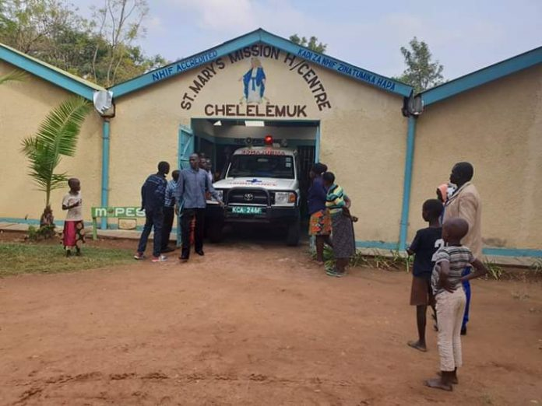
An ambulance moves the injured to Kocholia Sub County hospital for specialized treatment on Sunday December 9, 2018. Photo/Reuben Olita/Newsflash.
By Reuben Olita-Busia
Lightning struck Kakapel Village in Teso North Sub County on Saturday evening December 8 killing three members of one family and injuring three others.

Angurai South Ward Member of the County Assembly Grace Olita Omasete who visited the injured at St Mary’s Mission Centre, Chelelemuk Angurai on Sunday morning said three people died while three others were rushed to hospital.
The MCA said she made arrangements in partnership with the County Government for the husband, wife and their grandchild to be transferred to Kocholia Sub County Hospital for specialized treatment.

Omasete said those who succumbed to the lightning strike include first born daughter Esther Ateng’e, a standard seven pupil at Kwang’amor Primary School Millicent Amoit and Moses Imerikwa who is in top class at Kakapel Primary School.
Ateng’e who is married had visited her parents with her one-year-old son Imerikwa while Amoit who stays with her uncle in Kwangamor had come home for holiday. Abel Imai, 16, the late Esther’s immediate follower was not at home when tragedy struck.
Those critically injured include Andrew Idewa, his wife Caroline Idewa and their grandchild Rean Samuel.
The family members were struck while they were inside their house. The heavy storms that were experienced in most parts of the county also killed a cow of a primary school teacher a few kilometres away.
Omasete said lightning strikes are prone in her ward and appealed to the National and County Governments to install lightning arrestors in learning institutions and prone areas.
“Lightning struck Katakwa Primary School a few years ago killing two pupils. We have witnessed the same at Aedemoru and Kakapel where it has struck three times.

