**BY THE GUARDIAN REPORTER –** No Author Listed

Original link: HTTP://WWW.IPPMEDIA.COM/?L=79041

**Lightning kills 5, injures 18 at Easter mass**

**7th April 2015**

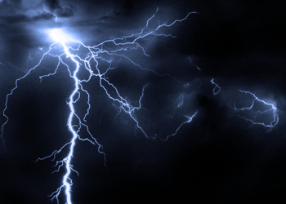

Lightning struck while Easter Mass was in progress at a Tanzania Assemblies of God church in Chato District, Geita District, leaving five people dead and 18 injured.

Geita Regional Police Commander Joseph Konyo confirmed the incident, saying those killed are Daud Medard (20), Daud Lazaro (20), Saimon Marco (15), Haile Shija (20) and Monica Sumuni (19).

He said four of the injured are admitted to Bwanga Dispensary, naming three of them as Mabula Mathias (8), Fabian Ezekiel (10) and Edina Leonard (21) and adding that the identity of the fourth was yet to be established.

Doctor In-charge at the dispensary Deogratias John, confirmed having received the 18 injured, saying 14 of them were discharged the very day they were admitted but the remaining four are still getting treatment at the health facility.

Commenting on the incident, the Councillor of the ward, Mahobe Chiza, said the incident was one of its kind to have taken place during Easter festivities.

“Believers were celebrating the Resurrection of Jesus Christ while it was raining. Then lightning struck killing five of them and injuring several others,” the Councillor said.

For his part, the church pastor, Deus Mhangwa, said his church has lost a good number of followers on the day they were celebrating the Resurrection of Jesus Christ.

“Everyone will die but the death of those Christians has come suddenly,” the pastor said.

He noted that the church as well as the nation has lost believers and manpower.

Incidents of lightning that end up killing many people are very common in western Tanzania’s regions of Kigoma, Kagera, Geita, Rukwa and Katavi.

In a similar incident, lightning struck at a school in Kigoma in February this year where six children and their teacher were killed, officials said.

"A teacher and six students died on the spot and 11 students were injured after they were struck by lightning in their classroom following heavy rains," the President's Office said in a statement.

The accident occurred on the weekend of February 22, this year.

President Jakaya Kikwete who called for calm from teachers and pupils said in a statement he was "shocked and saddened" by the incident, which occurred in Kigoma Region.

The schoolchildren killed by the striking lightning were aged between 11 and 14 years old, police officials said.

SOURCE: THE GUARDIAN

http://www.ippmedia.com/?l=79041