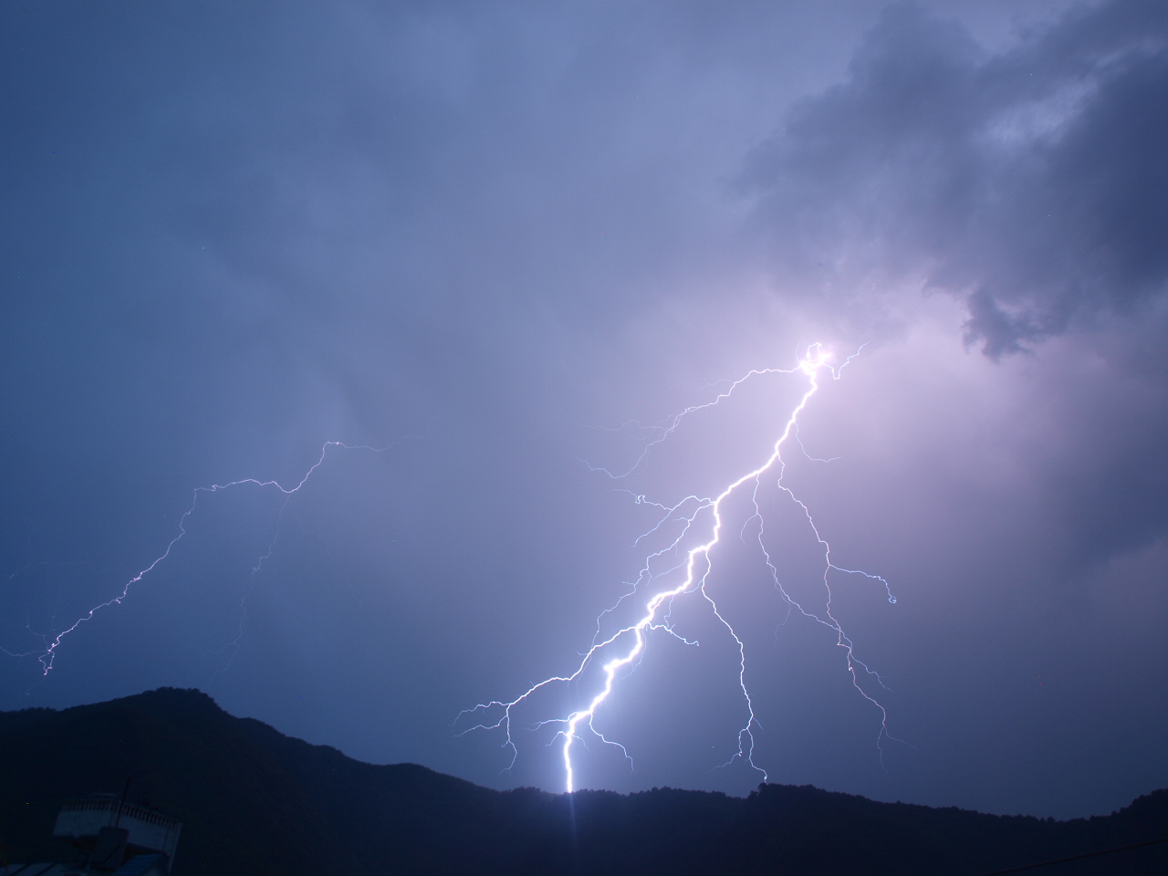

Date: 27-28, May, 2021

Time: 12:00 UTC

Zoom link: TBA – see registration page

**An Online Event**

**Preparing for International Lightning Safety Day 2021**

**Raising Awareness and Saving Lives**

**Preparing for Lightning Hazards**

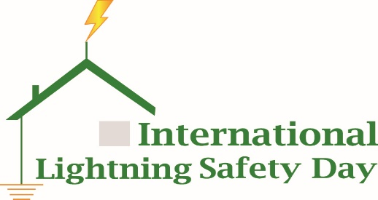

Organized by:

  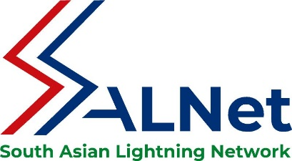

**Preparing for International Lightning Safety Day 2021**

**BACKGROUND:**

*Lightning is the* *most common weather Threat to Life* that most people in the world encounter – sometimes on a daily basis and often with little knowledge on how to avoid its ravages.

However, lightning, as a random, scattered, and unpredictable event remains, one of the least attended natural hazards around the globe even though it claims thousands of lives of both humans and livestock and damage other important physical property every year.

International Lightning Safety Day, 28 June 2021, marks the tenth anniversary of the day 18 children were killed and another 38 injured by a single lightning strike at Runyanya Primary School in Uganda.

The African Centres for Lightning and Electromagnetics (ACLENet), the Advanced Lightning, Power and Energy Research Centre (ALPER) and the South Asian Lightning Network (SALNet) cordially invite you to a networking opportunity on lightning safety to be held on 27-28 May 2021 as we prepare to commemorate ILSD. Meteorage, a France based firm, has proposed to take a lead on this year’s activities on 28th June 2021.

The aims of the ILSD2021preparatory conference are to:

1. Network and encourage collaboration between lightning safety advocacy programs
2. Lobby governments and non-government organizations of the respective nations for the declaration and marking of ILSD on 28th June
3. Plan various activities to mark ILSD on June 28
4. Update and gain information for these programs
5. Solicit involvement from leaders who are working in different sectors of disaster risk reduction including the WMO, UN, and national agencies

‘Preparing for ILSD-2021’ builds on [ILSD-2020](https://www.youtube.com/watch?v=W6PSiiZ26j0), a very successful conference, and we look forward to hearing about each country’s plans for observing ILSD-2021.

**___________________________________**

**Registration is FREE at https://aclenet.org/preparing-for-ilsd2021-registration.html**

The program will be recorded and posted afterwards.

**___________________________________**

THANK YOU FOR JOINING US –

MARY ANN COOPER, MD – [macooper@uic.edu](mailto:macooper@uic.edu) – ACLENet

PROF Ir DR MOHD ZAINAL ABIDIN AB KADIR - [mzk@upm.edu.my](mailto:mzk@upm.edu.my) - ALPER

SHRI RAM SHARMA, PhD - [ramhome2@hotmail.com](mailto:ramhome2@hotmail.com) – SALNet

**PROGRAM AND SPEAKERS**

NOTE: all times UTC (use WorldTimeBuddy or similar program to find your time)

**DAY 1 – Thursday - 27 May 2021**

|  |  |  |  |  |
| --- | --- | --- | --- | --- |
| **Agenda** | **Speaker** | **Country** |  | **Time** |
| Welcome and Introduction | Shriram Sharma, SALNet | Nepal | 10 | 1200 |
| Overview – review of ILSD2020 | Mary Ann Cooper, ACLENet, macooper@uic.edu | USA | 14 |  |
| The Need for International Solidarity in the Fight Against the Lightning Hazard | Hilary Onek, Hon Minister of Disaster Preparedness, Uganda | Uganda | 10 |  |
| A WMO Perspective on Lightning | Cyrille Honoré, Director, Disaster Risk Reduction and Public Services Branch, (DPS), [chonore@wmo.int](mailto:chonore@wmo.int) | WMO | 12 |  |
| Lightning Safety Policy Development and Its Impact on the Public and Industry | Chandima Gomes, CEHVE, University of Witwatersrand [chandima.gomes@gmail.com](mailto:chandima.gomes@gmail.com) | South Africa | 12 |  |
| Issue and mitigation on lightning protection in Malaysia: Role of the Energy Commission | Zakuan Ibrahim  Energy Commission of Malaysia | Malaysia | 10 | 1300 |
| Impact of Awareness - an experience from USA and ILSD2021 plans - NOAA and NLSC resources free to all | John Jensenius  National Lightning Safety Council  john.jensenius@gmail.com | USA | 12 |  |
| Lightning by the Numbers: How much is occurring? | Chris Vagasky, Vaisala  chris.vagasky@vaisala.com | USA | 12 |  |
| Comparison of Lightning Detection Technologies and Results | Daile Zhang, University of Maryland, dlzhang@umd.edu | USA | 12 |  |
| How to Do a Demographic Study | Ron Holle, Holle Meteorology and Photography, [rholle@earthlink.net](mailto:rholle@earthlink.net) | USA | 12 |  |
| Pilot of Lightning Warning System for Small Rural Areas in South Africa | Dr. Maqsooda Mahomed, University KZN, [maqsoodamahomed@gmail.com](mailto:maqsoodamahomed@gmail.com) | South Africa | 12 |  |
| Communication Tools for Building a Lightning Safe Communities Campaign | Kim Loehr, Loehr Lightning  kim@loehrlightning.com | USA | 12 | 1400 |
| Transmission Line Lightning Improvement Initiatives Utilizing Local Lightning Data | Noradlina Abdullah, TNB Research [noradlina.abdullah@tnb.com.my](mailto:noradlina.abdullah@tnb.com.my) | Malaysia | 10 |  |
| Establishing a Lightning Research Centre: CELP’s Experience | Zainal Kadir, Universiti Putra Malaysia, [mzk@upm.edu.my](mailto:mzk@upm.edu.my) | Malaysia | 10 |  |
| Marking the 10th Anniversary of Runyanya Lightning Disaster and What ACLENet is Doing to Prevent Future Lightning Disasters in Africa | Richard Tushemereirwe ACLENet richadt2002@yahoo.com | Uganda | 12 |  |
| Q&A Session | Zainal Kadir, ALPER | Malaysia | 30 | 1500 |
| Concluding Remarks  Details for Day 2 | ShriRam Sharma |  | 10 |  |

**Day 2 – Friday - 28 May 2021**

|  |  |  |  |  |
| --- | --- | --- | --- | --- |
| **Agenda** | **Speaker** | **Country** |  | **Time** |
| Intro – greetings | Mary Ann Cooper, ACLENet  macooper@uic.edu | USA | 10 | 1200 |
| Towards Improved Lightning Safety in the Caribbean | Arlene Laing, CMO | Caribbean | 10 |  |
| Simplifying structural lightning protection | Alexis Barwise, LPC Concept  [alexis@lpconcepts.com](mailto:alexis@lpconcepts.com) | South Africa | 12 |  |
| Challenges to implementing LP standards in developing nations | Gopa Kumar, LARC, Kerala  gopa0904@gmail.com | India | 12 |  |
| LP challenges in developing countries – LPWG experience | Mitch Guthrie, IEC TC81 mitchellguthrie@embarqmail.com | USA | 12 |  |
| **Lightning Safety Advocacy Programs** |  |  |  |  |
| Challenges in Mitigating Lightning Hazard in China | Prof Zhou, Shanghai University | China | 10 | 1300 |
| Mass Awareness and its effects in the state of Kerala | Gopa Kumar, LARC, Kerala  gopa0904@gmail.com | India | 10 |  |
| Challenges in Mitigating the Lightning Hazard in Bangladesh | Dr. Munir Ahmed (or designee) [munir.tara@gmail.com](mailto:munir.tara@gmail.com) | Bangladesh | 10 |  |
| Role of SALNet in the mitigation of Lightning hazards across the region | Dr. Shriram Sharma, SALNET [ramhome2@hotmail.com](mailto:ramhome2@hotmail.com) | Nepal | 10 |  |
| Bhutan | Parashuram Sharma parashuramsharma@jnec.edu.bt | Bhutan | 10 |  |
| Mitigating Efforts of Lightning Hazards in Sri Lanka | Nuwan Kumarasinghe [nuwan1960@gmail.com](mailto:nuwan1960@gmail.com) | Sri Lanka | 10 |  |
| Egyptian standards for building lightning protection | Nayel Mohamed, PhD, Assiut University  Mohamed.nayel@aun.edu.eg | Egypt | 10 | 1400 |
| Challenges of mitigating lightning hazard in Zambia and the role of ZaCLIR | Foster Lubasi, ZACLIR, chile2015lubs@gmail.com | Zambia | 10 |  |
| Lightning Advocacy in the Republic of South Africa | Ryan Blumenthal, MD/PhD, Univ Pretoria, [docmagic@gmail.com](mailto:docmagic@gmail.com) | South Africa | 10 |  |
| Statistics of Lightning Accidents in Brazil and ILSD BRAZIL activities | Helio Eiji Sueta, IEE/USP  [sueta@iee.usp.br](mailto:sueta@iee.usp.br) | Brazil | 10 |  |
| Projection of Lightning Safety in Colombia | Daniel Esteban Villamil [devillamils@correo.udistrital.edu.co](mailto:devillamils@correo.udistrital.edu.co) | Colombia | 10 |  |
| Plans and invitation to ILSD2021 28 June Webinar | Stephane Schmitt [stephane.schmitt@meteorage.com](mailto:stephane.schmitt@meteorage.com) | France | 10 | 1500 |
| Q&A Session | Zainal Kadir, ALPER | Malaysia | 30 |  |
| Concluding Remarks | Mary Ann Cooper |  | 10 |  |

THANK YOU FOR ATTENDING!

MACooper, ZAKadir, SSharma