Lightning Kills One, Injures Two Others in Namisindwa [Uganda]

27 Oct 2020 10:28
https://ugandaradionetwork.net/story/lightning-kills-one-injures-two-in-namisndwa-district
Tsemwire Aron Fredrick Freelancer
The area LC I Chairperson, John Wamalabe has identified the deceased as Cyrus Wasibala while the injured are Emma Bwayo and Douglas Bwayo. Emma Bwayo is admitted at Magale Health Center 1V while Douglas Bwayo is being nursed at home.

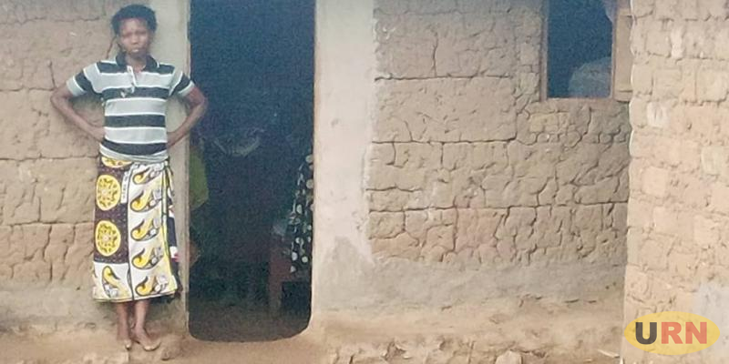
Jackline Misanyo, the wife to the deceased

