Lightning kills couple in Suba North, man drowns in Karachuonyo

Kenya.
24 April 2023 - 15:04
https://www.the-star.co.ke/counties/nyanza/2023-04-24-lightning-kills-couple-in-suba-north-man-drowns-in-karachuonyo/

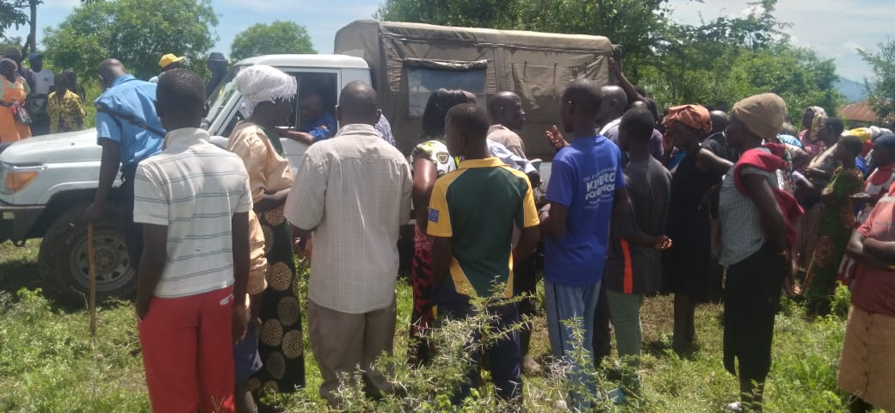
• Josephat Otieno, 34, and his wife Jael Anyango, 28, were killed by lightning at Aluor village in Suba North constituency.
• The couple was found dead on the floor on Monday when some family members went to check on them in their house.
Josephat Otieno, 34, and his wife Jael Anyango, 28, were killed by lightning at Aluor village in Suba North constituency. Their two daughters escaped unhurt.
The couple was found dead on the floor on Monday when some family members went to check on them in their house.
They were struck and died instantly as they watched TV.
The lightning also broke electric cables used for supplying power in the house from a solar panel.
“We were surprised when we woke up and found the couple dead. We think they were killed by lightning which occurred during the Sunday night heavy rainfall,” a family member said.
Lambwe East Location Chief Bernard Ouma said the couple’s two daughters aged six and four years escaped the tragedy.
The incident seemingly occurred when the children were already asleep.
The girls found out about the tragedy Monday morning after family members opened the door.
“A family member who opened the door found the two children sleeping in chairs. The children didn’t know the incident had occurred,” Ouma said.

