Lightning Kills 5 Cows from Man of God’s Farm- Uganda

November 21, 2023

https://onion.co.ug/lightning-kills-5-cows-from-man-of-gods-farm/

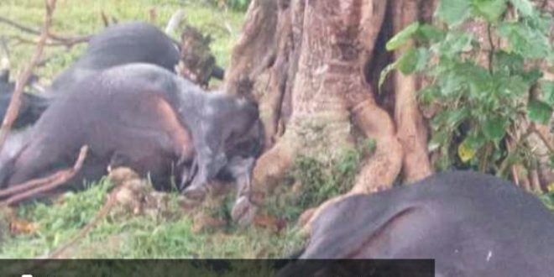
Incident 1
In a tragic event on November 21, 2023, lightning struck and killed five cows owned by retired cleric Rev. Moses Wanyibe in Khaukha village, Wanale Sub County, Mbale district. The incident took place during heavy rainfall accompanied by thunder.
The cows were grazing in the farm when the rain started, and seeking shelter under a tree proved fatal as they were all struck by lightning, resulting in instant death.
Rev. Wanyibe, present during the incident, described it as a devastating loss. The force of the lightning was so intense that he lost consciousness and fell off his chair. Upon regaining consciousness, he witnessed the heartbreaking sight of his lifeless cows beneath the tree.
Incident 2
This unfortunate incident is the second lightning strike within a week in the district. On November 14, 2023, in Buwasu village, a 12-year-old boy named Shibuta was fatally struck by lightning while seeking shelter at a neighbor’s house.

