**Eastern Cape initiate killed by lightning as more thunderstorms expected for the province – South Africa**

Malibongwe Dayimani

https://www.news24.com/news24/southafrica/news/eastern-cape-initiate-killed-by-lightning-as-more-thunderstorms-expected-for-the-province-20211214

14 Dec 2021

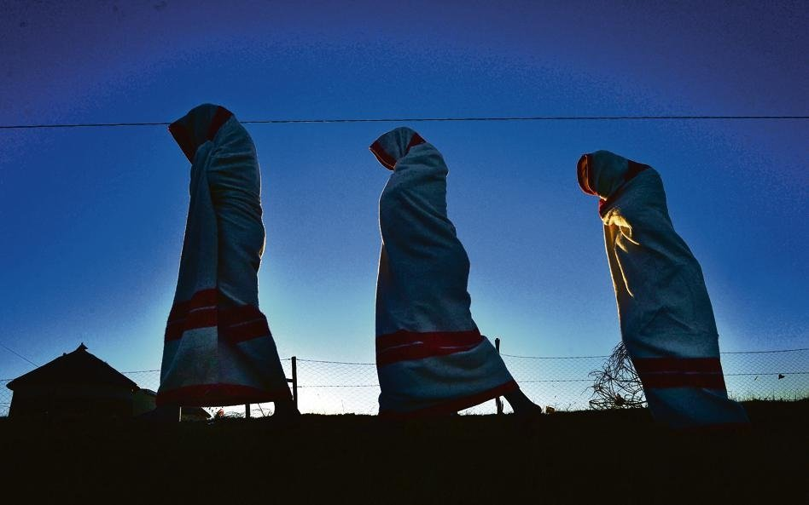

An initiate was killed during heavy storms in Eastern Cape. (Photo: Leon Sadiki/City Press)

* **More thunderstorms are expected to lash the Eastern Cape on Wednesday.**
* **A 19-year-old initiate died after he was struck by lightning in Mdantsane.**
* **It brings the death toll with regard to initiates to 23 in the Eastern Cape.**

A 19-year-old initiate died after he was struck by lightning in Mdantsane, in the Eastern Cape, as thunderstorms lashed the eastern parts of the province on Monday afternoon.

Eastern Cape police spokesperson Brigadier Thembinkosi Kinana said the incident took place inside a hut occupied by three initiates at around 17:00.

He said, on arrival, NU15's Inyibiba Police found "the body of a 19-year-old initiate that was allegedly struck by lightning. The other initiate, a 17-year-old, was seriously injured. The third initiate, age unknown, was left unharmed."

**READ |**[**More thunderstorms to lash Eastern Cape after 6 die during heavy rains, strong winds**](https://www.news24.com/news24/southafrica/news/more-thunderstorms-to-lash-eastern-cape-after-6-die-during-heavy-rains-strong-winds-20211213)

Kinana said an inquest was opened for investigation.

It brings the death toll in the province, with regard to initiates, to 23 for this current initiation season.

Cooperative governance and traditional affairs spokesperson Mamakeli Ngam said: "We can confirm that 23 initiates have died and post-mortem investigations will be conducted to determine the cause of death."

The initiation season comes to an end in January.

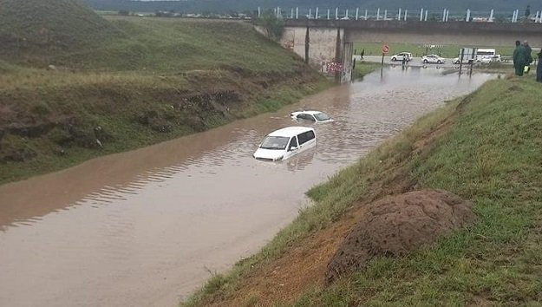

Cars are submerged during heavy rains in the Eastern Cape.Supplied

On Monday afternoon, hail, heavy downpours, excessive lightning and strong damaging winds battered large parts of the province, including the Buffalo City Metro and the Amathole District Municipality.

**Damaged**

Buildings of the Unathi High School in Cambridge Location and Winterberg Agricultural School in Fort Beaufort were severely damaged.

Traffic officers' vehicles at the offices of the transport department, in Dimbaza and Fort Beaufort, were damaged by golf ball-sized hailstones and giant trees were uprooted, said the transport department.

The Matatiele Local Municipality announced that large parts of the town were left without power after strong winds affected the powerlines on Monday night.

South African Weather Service meteorologist Lelo Kleinbooi said heavy downpours resulted in flash flooding in places over the Enoch Mgijima Local Municipality in Komani, Amahlathi Local Municipality in Stutterheim, Buffalo City Metro (mainly Qonce and Berlin), Raymond Mhlaba Local Municipality and OR Tambo in Mthatha.

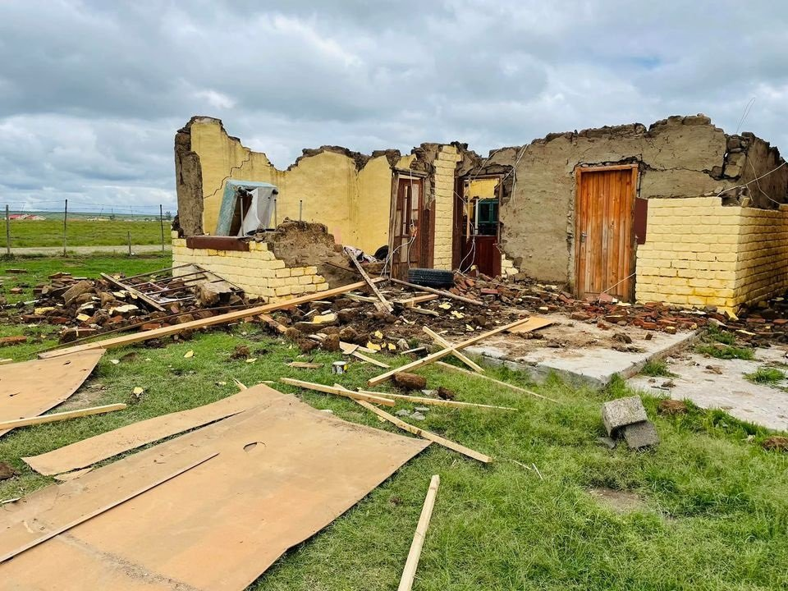

Houses in Alice, in the Raymond Mhlaba Municipality have been damaged by thunderstorms.News24Xolani Sitshinga

"Most of the impacts were experienced from the afternoon into the evening, with the earliest severe thunderstorm observed at about 13.30 around the Raymond Mhlaba Local Municipality and then progressed eastwards," said Kleinbooi.

Asked if the storm was over for the province, Kleinbooi said: "Unfortunately not, there is a chance of severe thunderstorms in places over the OR Tambo and Chris Hani District Municipalities, Amahlathi, Great Kei, Mnquma, Mbhashe, Walter Sisulu, Senqu and Elundini Local Municipalities for Wednesday afternoon.

"These severe thunderstorms may produce the following: heavy downpours, damaging winds, hail and excessive lightning, which is expected to result in localised damage to property, vehicles and livestock, with some impact on livelihoods as well."

The education and transport departments, as well as Eskom, had not done full accounting of the damage caused by the storm at the time of writing. Their responses will be added once received.

Since Thursday last week, thunderstorms had been wreaking havoc across large parts of the province and continued throughout the weekend into Monday afternoon.

In the former Transkei, around Mthatha, Libode and Qumbu, six people were confirmed dead, while 142 were left without homes.

More than 230 animals died due to the impact of the adverse weather.