

**Lightning Strikes 16 Dead Inside Seventh Day Adventist Church (Rwanda)**

[**WORLD NEWS**](https://elombah.com/index.php/category/world-news/)[**WORLD NEWS**](https://elombah.com/index.php/category/world-news-2/)

[By **ElombahNews**](https://elombah.com/index.php/author/elombah/) Last updated **Mar 11, 2018**

<https://elombah.com/index.php/world-news/lightning-strikes-16-dead-inside-seventh-day-adventist-church/>

[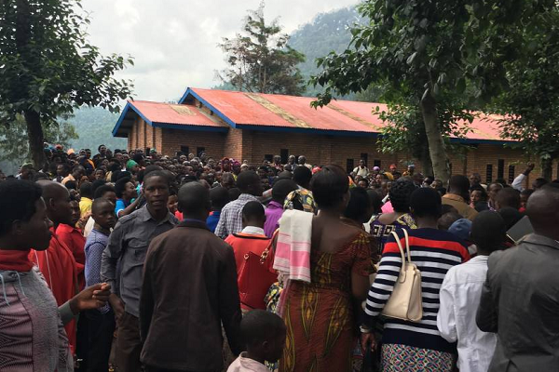](https://elombah.com/wp-content/uploads/2018/03/Seventh-Day-Adventist-Church-Rwanda.png)

[Lightning has struck a Seventh Day Adventist Church](http://www.nan.ng/news/lightning-kills-16-inside-seventh-day-adventist-church/) in Rwanda, killing no fewer than 16 people and injuring dozens more, a local official said Sunday.

Fourteen victims were killed on the spot as lightning hit the church in the Nyaruguru district in the Southern Province on Saturday, local mayor Habitegeko Francois told AFP over the phone.

Two others died later from their injuries, he said.

Nyaruguru is a district (akarere) in Southern Province, Rwanda. Its capital is Kibeho, a pilgrimage site of the Catholic Church. Geography.

The district is the most southerly in Rwanda, lying between the cities of Butare and Cyangugu and along the Burundian border.

He added that 140 people involved in the incident had been rushed to hospital and district health centres, but that many had already been discharged.

“Doctors say that only three of them are in critical condition but they are getting better,” he said.

According to the mayor, a similar accident took place on Friday when lightning struck a group of 18 students, killing one of them.