Pupil killed, 21 injured as lightning strikes Kakamega school [Kenya]
Saturday May 26 2018
https://www.nation.co.ke/counties/kakamega/Pupil-killed--21-injured-as-lightning-strikes-Kakamega-school/3444890-4580602-p3rfjy/index.html
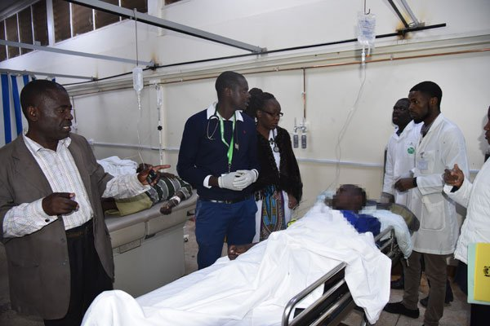
Doctors attend to students who were struck by lightning in Kakamega on May 25, 2018. A Class Eight pupil at Ebushibo Primary School died and 21 others were injured when the lightning struck the group that was hurdled together in a classroom during heavy rains. PHOTO | ISAAC WALE | NATION MEDIA GROUP
A pupil has been killed and 21 others taken to hospital after being struck by lightning in Kakamega County.
The Class Eight pupil at Ebushibo Primary School in Navakholo sub-County died at the home of a retired nurse where she was rushed for first aid treatment.
The 21 pupils who sustained minor injuries were taken to Kakamega County Teaching and Referral Hospital.
"One pupil from Ebushibo Primary School died after being struck by lighting and 21 others sustained burns in the incident at Esumeiya Primary School," said Navakholo OCPD Paul Kuria.
Ebushibo Primary School head teacher Agneta Wawire said the incident occurred at around 6pm at Esumeiya Primary School where pupils were participating in a sporting event.
“We had just finished school cluster ball games with Eshienga Primary School when it started raining heavily. The pupils went to take shelter at the classrooms when the lightning struck”, said Ms Wawire.
Ms Wawire said they took the pupils to a nearby home of a retired nurse Ms Catherine Sande for first aid treatment.
The school head teacher has asked the government to install more lightning arrestors to prevent such incidents.
Navakholo MP Emmanuel Wangwe said they had initially installed four arrestors in the sub county last year but promised to meet with CDF committee members on Saturday to add two more near the school.

