
Lightning strikes 40 pupils (Uganda)
By Vision Reporter
Added 25th November 2011 01:01 PM
FIFTEEN children were critically injured in the thunder bolt that hit Kyenzige Model Primary School in Kibaale district during a midday drizzle
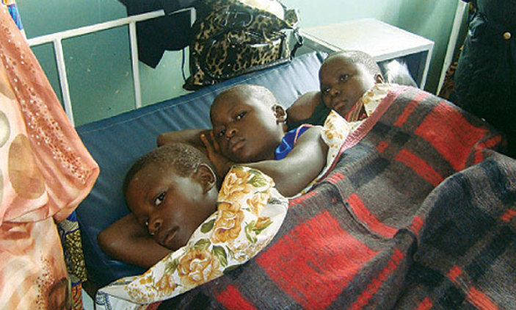
By Ismael Kasooha in Kibaale
HAD the parents of Kyenzige Model Primary School in Kibaale district been able to raise the required sh1.5m to install lightning conductors, yesterday’s tragedy in which 40 pupils were struck by lightning would have been averted.
Fifteen children were critically injured in the thunder bolt that hit the school during a midday drizzle.
Karubanga the headteacher said the school does not have lightning conductors and attributed the tragedy to that. He however, said the school management and parents had started contributing money to install the conductors.
“We had collected over sh550,000 from parents to buy the conductors but we could not get them because they are estimated to cost sh1.5m,” Karubanga said.
He said they had just told the pupils to stop playing in the rain when they heard a loud bang.
“We saw the pupils fall to the ground and others running away in fear,” he said.
Good Samaritans rushed the injured to Kagadi hospital. Dinah Twinomujuni, the clinical officer at the out-patients department at Kagadi hospital, said they were overwhelmed by the big number of the victims and were forced to suspend activities in other wards so as to attend to the pupils.
“The pupils were vomiting, had paralysed legs and hands and complained of chest pain, headache and stomachache for those who could talk.”
Twinomujuni added that 15 had been admitted while the remaining 25 were treated and discharged. She asked school administrations to install lightning conductors to avoid such tragedies.
Some of the pupils admitted include Eviline Kusemererwa, 14, Rosemary Tuhaise, 13, John Kiiza, 14, Resty Kyalikunda, 15, Margaret Musimenta, 15, Joseph Kiiza, 15, Francis Tumwesige, 14, and Rosemary Atugonza, 11.
When New Vision visited the wards the children were admitted in, it was discovered that some were lying on the floor and others were sharing beds.
One of the pupils, Oliver Nankya, said they had just completed their science test and were standing on the verandah when the lightning struck.
The deputy head teacher said most pupils were barefoot but even those who had sandals were not spared.
Kyenzige Model Primary School has a population of 565 pupils.

